

**ONLINE SHOPPING**

**Software Design Document**

– Hanoi, September 2021 –

**Table of Contents**

I. Overview 10

Code Packages/Namespaces 10

II. Code Designs 12

1. Feature Product 12

a. Class Diagram 12

b. Class Specifications 12

c. Sequence Diagram(s) 13

d. Database queries 13

2. Search & Filter Product 14

a. Class Diagram 14

b. Class Specifications 14

c. Sequence Diagram(s) 15

d. Database queries 15

a. Class Diagram 16

b. Class Specifications 16

c. Sequence Diagram(s) 16

d. Database queries 17

4. Change Amount 17

a. Class Diagram 17

b. Class Specifications 17

c. Sequence Diagram(s) 18

d. Database queries 18

5. Delete Product From Cart 19

a. Class Diagram 19

b. Class Specifications 19

c. Sequence Diagram(s) 20

d. Database queries 20

6. Delete All Cart Item 21

a. Class Diagram 21

b. Class Specifications 21

c. Sequence Diagram(s) 22

d. Database queries 22

7. Login 23

a. Class Diagram 23

b. Class Specifications 23

c. Sequence Diagram(s) 24

d. Database queries 24

8. Register 25

a. Class Diagram 25

b. Class Specifications 25

c. Sequence Diagram(s) 26

d. Database queries 26

9. View User List 27

a. Class Diagram 27

b. Class Specifications 27

c. Sequence Diagram(s) 28

d. Database queries 28

10. Edit User 29

a. Class Diagram 29

b. Class Specifications 29

c. Sequence Diagram(s) 31

d. Database queries 31

11. Delete User 31

a. Class Diagram 31

b. Class Specifications 31

c. Sequence Diagram(s) 33

d. Database queries 33

12. Customers List[Seller] 34

a. Class Diagram 34

b. Class Specifications 34

c. Sequence Diagram(s) 35

d. Database queries 35

13. Add Ship Information 35

a. Class Diagram 35

b. Class Specifications 35

c. Sequence Diagram(s) 36

14. Change Ship Information 36

a. Class Diagram 36

b. Class Specifications 37

c. Sequence Diagram(s) 37

d. Database queries 37

a. Class Diagram 38

b. Class Specifications 38

c. Sequence Diagram(s) 39

16. Change Password 40

a. Class Diagram 40

b. Class Specifications 40

c. Sequence Diagram(s) 41

d. Database queries 41

17. User Profile 42

a. Class Diagram 42

b. Class Specifications 42

c. Sequence Diagram(s) 43

18. My Orders 43

a. Class Diagram 43

b. Class Specifications 43

c. Sequence Diagram(s) 44

19. Order Information 45

a. Class Diagram 45

c. Sequence Diagram(s) 46

d. Database queries 46

d. Database queries 49

22. Order Details 50

a. Class Diagram 50

b. Class Specifications 50

c. Sequence Diagram(s) 51

d. Database queries 51

23. View Feedback 52

a. Class Diagram 52

b. Class Specifications 52

c. Sequence Diagram(s) 53

d. Database queries 53

24. Send Feedback 53

a. Class Diagram 53

b. Class Specifications 53

c. Sequence Diagram(s) 54

d. Database queries 54

25. Blogs List 55

a. Class Diagram 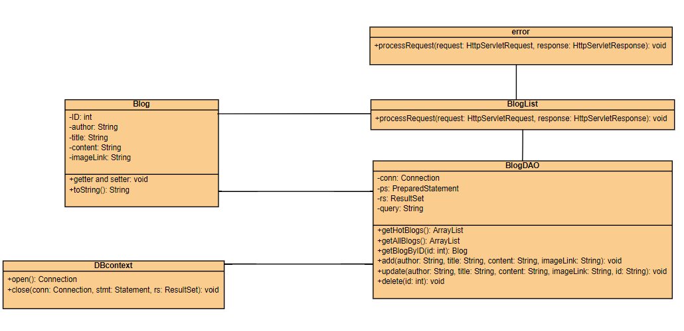 55

b. Class Specifications 55

c. Sequence Diagram(s) 56

d. Database queries 56

26. Blog Details 56

a. Class Diagram 56

b. Class Specifications 56

c. Sequence Diagram(s) 57

d. Database queries 57

27. Blog Management 58

a. Class Diagram 58

b. Class Specifications 58

c. Sequence Diagram(s) 59

d. Database queries 59

28. View Notification 60

a. Class Diagram 60

b. Class Specifications 60

c. Sequence Diagram(s) 61

d. Database queries 61

29. Mark as Read 62

a. Class Diagram 62

b. Class Specifications 62

c. Sequence Diagram(s) 63

d. Database queries 63

30. Admin Feature 64

a. Class Diagram 64

b. Class Specifications 64

c. Sequence Diagram(s) 65

d. Database queries 65

31. Add Product 66

a. Class Diagram 66

b. Class Specifications 66

c. Sequence Diagram(s) 67

d. Database queries 67

32. Delete Product 68

a. Class Diagram 68

b. Class Specifications 68

c. Sequence Diagram(s) 69

d. Database queries 69

33. Edit Product 70

a. Class Diagram 70

b. Class Specifications 70

c. Sequence Diagram(s) 71

d. Database queries 71

34. Orders Dashboard 71

d. Database queries 74

35. PostDetail 75

b. Class Specifications 75

PostControl Class: The doGet function is used to get the ID of the post and then use the doPost function to edit the product 75

DeletepostControll Class: use process request function to get and delete post by ID 76

c. Sequence Diagram(s) 76

d. Database queries 77

b. Class Specifications 78

PostManageControl Class: This class process request for list of post create by user ID 78

d. Database queries 79

37. Error 80

a. Class Diagram 80

b. Class Specifications 80

c. Sequence Diagram(s) 80

d. Database queries 80

38. Manage Feedback [Seller] 81

a. Class Diagram 81

b. Class Specifications 81

c. Sequence Diagram(s) 82

d. Database queries 82

39. Manage Feedback [Customer] 82

a. Class Diagram 82

b. Class Specifications 82

c. Sequence Diagram(s) 83

d. Database queries 83

40. Manage Banner 84

a. Class Diagram 84

b. Class Specifications 84

c. Sequence Diagram(s) 85

d. Database queries 85

41. Chat 86

a. Class Diagram 86

b. Class Specifications 86

c. Sequence Diagram 88

43. Marketing Dashboard 90

a. Class Diagram 90

b. Class Specifications 90

c. Sequence Diagram(s) 91

d. Database queries 91

43. DeliveryJob 92

a. Class Diagram 92

b. Class Specifications 92

c. Sequence Diagram(s) 93

d. Database queries 93

44. Delivery Details 94

a. Class Diagram 94

b. Class Specifications 94

c. Sequence Diagram(s) 95

d. Database queries 95

III. Database Tables 96

1. Database Schema 96

2. Table Description 96

# I. Overview

Technical

* Tool
* netbeans 8.0
* ms sql server 2018
* Framework
* bootstrap 5.0.2
* jquery

## Code Packages/Namespaces

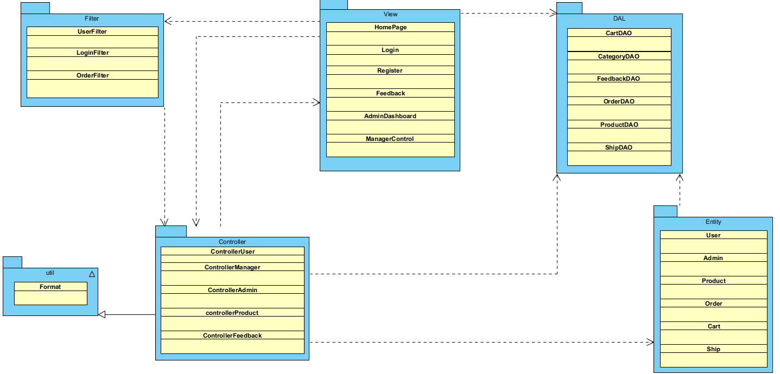

w

***Package descriptions & package class naming conventions***

|  |  |  |
| --- | --- | --- |
| **No** | **Package** | **Description** |
| *01* | *View(Web Pages)* | *Provide interaction with user ,GUI*  *Java Class Naming Convention* |
| *02* | *Controller* | *Control the data flow between view and model (DAO),Control the logic of the system*  *Java Class Naming Convention* |
| *03* | *DAL* | *Provide the connection to the Database, Extract data for the system* |
| *04* | *Filter* | *Control the redirection between Pages in View and from View to Controller*  *Java Class Naming Convention* |
| *05* | *Entity* | *Define the logic of data extracted from Database*  *Java Class Naming Convention* |
| *06* | *Utity* | *Utility Function* |

# 

# 

# II. Code Designs

## 1. Feature Product

### a. Class Diagram

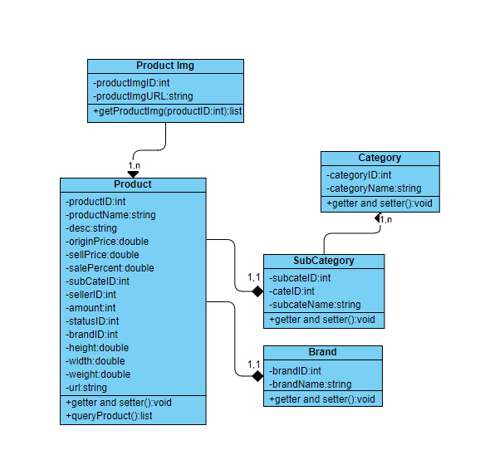

### b. Class Specifications

|  |  |  |
| --- | --- | --- |
| **No** | **Method** | **Description** |
| *01* | *getAllProduct()* | *Query will get all product from database* |

### c. Sequence Diagram(s)

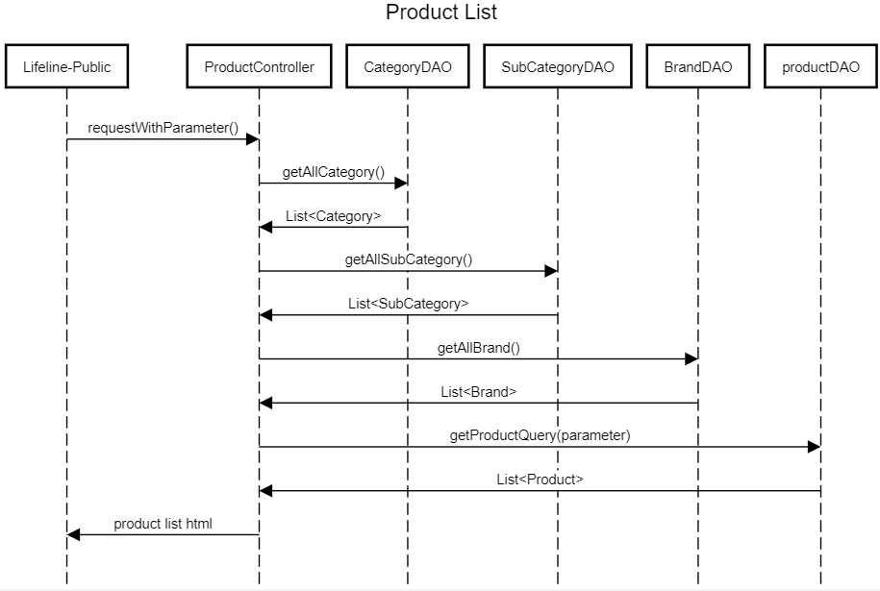

### d. Database queries

* select p.ProductID , ProductName , Description , OriginalPrice , SellPrice , SalePercent ,SubCategoryID , SellerID , Amount , StatusID , StatusID ,BrandID , height , width ,weight , s.ProductImgURL from Product p join ProductImg s on p.ProductID = s.ProductID

## 2. Search & Filter Product

### a. Class Diagram



### b. Class Specifications

Product

|  |  |  |
| --- | --- | --- |
| **No** | **Method** | **Description** |
| *01* | *getProductQuery(Query,subcate,brand,price,sortType,sortMode)* | *Query product from database with input parameter* |

### c. Sequence Diagram(s)

**

### d. Database queries

* SELECT * FROM dbo.ProductImg where ProductID = ?
* SELECT p.ProductID , ProductName , Description , OriginalPrice , SellPrice , SalePercent , SubCategoryID , SellerID , Amount , StatusID , StatusID ,BrandID , height , width ,weight , s.ProductImgURL from Product p join ProductImg s on p.ProductID = s.ProductID WHERE p.ProductName LIKE ? AND p.StatusID!= 2 AND p.Amount>0 [ AND SubCategoryID = ? ] [ AND BrandID = ? ] [AND p.SellPrice< ? AND p.SellPrice>= ? ] [ ORDER BY [ parameter ] ] [ ASC /DESC ]

**3. View Product Detail**

### a. Class Diagram

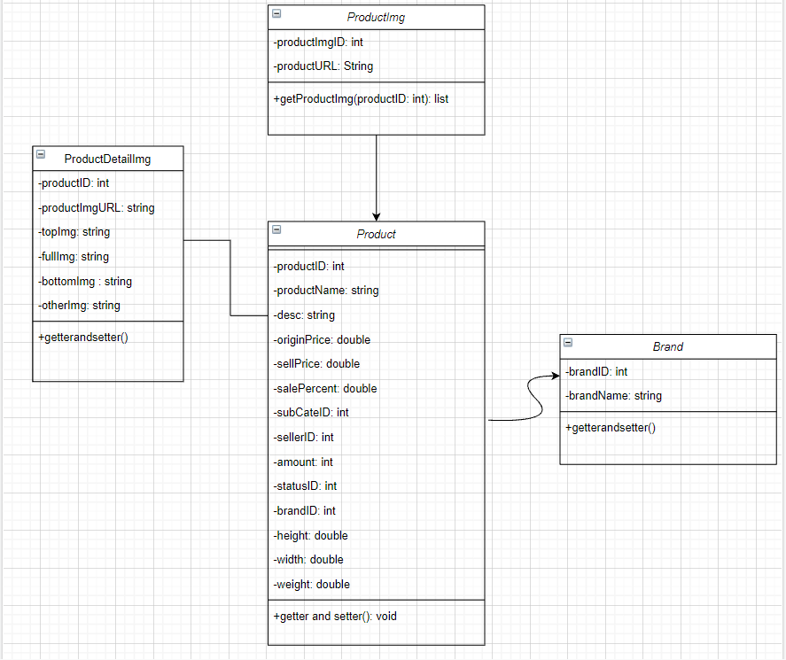

### b. Class Specifications

|  |  |  |
| --- | --- | --- |
| **No** | **Method** | **Description** |
| *01* | *GetProductDetailsByProductID* | *Traverse from beginning to end all rows in the product table in the database* |

### c. Sequence Diagram(s)

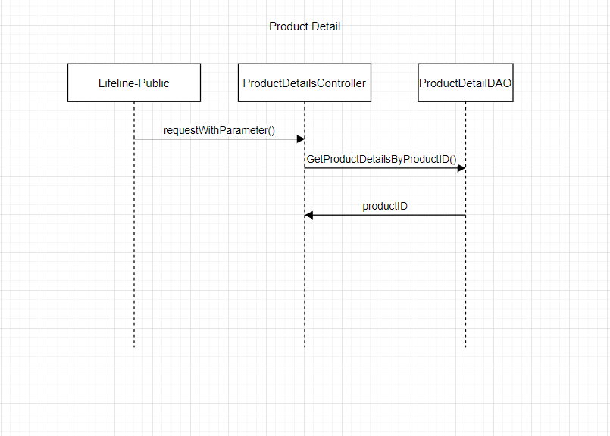

### 

### d. Database queries

SELECT * from Product

JOIN ProductImg

ON Product.ProductID = ProductImg.ProductID

WHERE Product.ProductID = ?

## 4. Change Amount

### a. Class Diagram

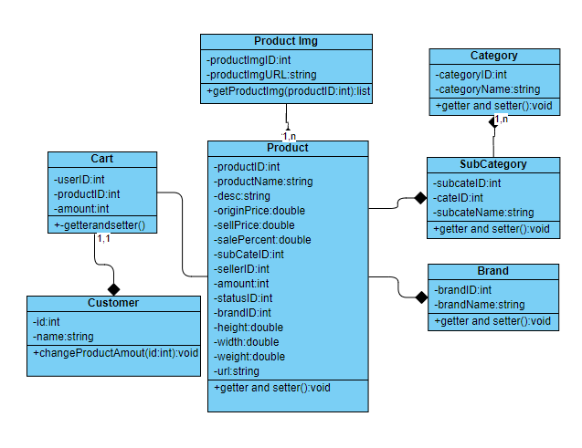

### b. Class Specifications

Customer

|  |  |  |
| --- | --- | --- |
| **No** | **Method** | **Description** |
| *01* | *changeProductAmount()* | *Add or reduce amount of a product from cart* |

### c. Sequence Diagram(s)

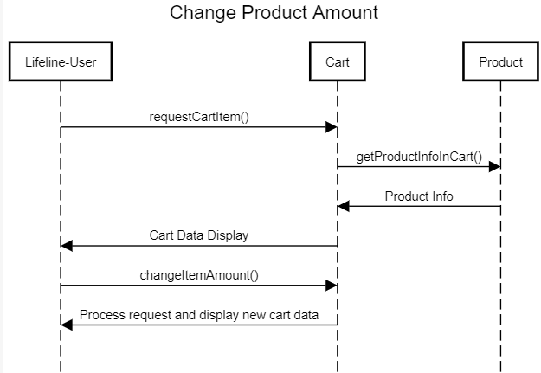

### d. Database queries

UPDATE dbo.cart

SET amount = ?

WHERE userID = ? and productID = ?

## 5. Delete Product From Cart

### a. Class Diagram

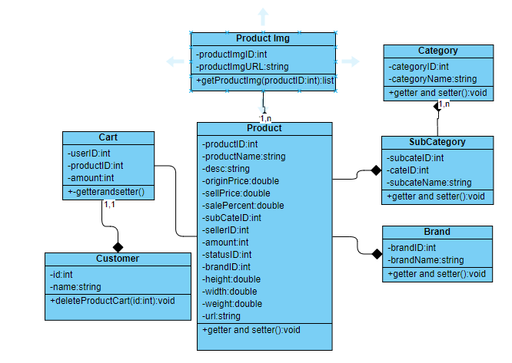

### b. Class Specifications

Customer

|  |  |  |
| --- | --- | --- |
| **No** | **Method** | **Description** |
| *01* | *deleteProductCart()* | *Remove a product() from cart* |

### c. Sequence Diagram(s)

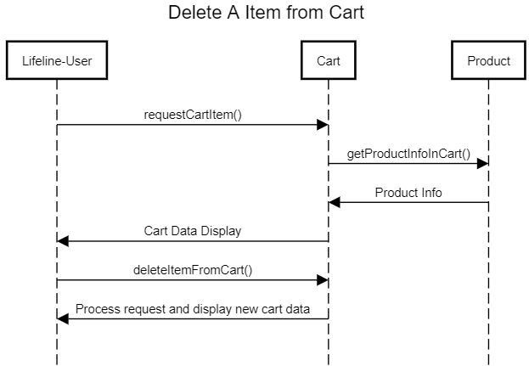

### d. Database queries

DELETE FROM *dbo.cart* WHERE *userID= ? and* productID = ?

## 6. Delete All Cart Item

### a. Class Diagram

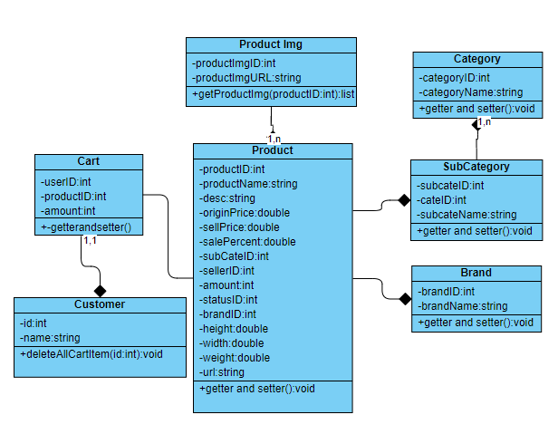

### b. Class Specifications

Customer

|  |  |  |
| --- | --- | --- |
| **No** | **Method** | **Description** |
| *01* | *deleteAllCartItem()* | *Remove every item from cart* |

### c. Sequence Diagram(s)

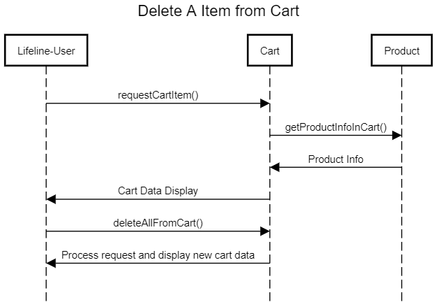

### d. Database queries

DELETE FROM *dbo.Cart* WHERE *UserID = ?*;

## 7.

### a. Class Diagram

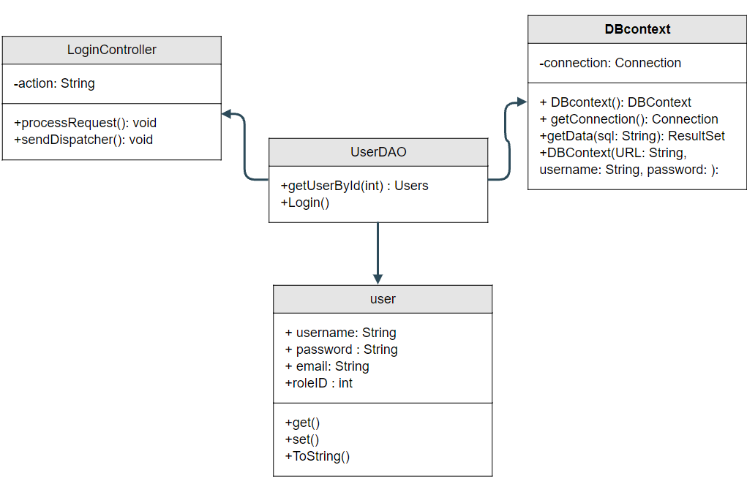

### b. Class Specifications

UserController

|  |  |  |
| --- | --- | --- |
| No | Method | Description |
| 01 | processRequest() | get all new information from user Form and update the database |
|  |  |  |

UserDAO

[Provide the detailed description for the class methods]

|  |  |  |
| --- | --- | --- |
| No | Method | Description |
| 01 | getUserList() | get the list of user |
| 02 | getUserById(int uId) | get the user where the user id is |

### 

### c. Sequence Diagram(s)

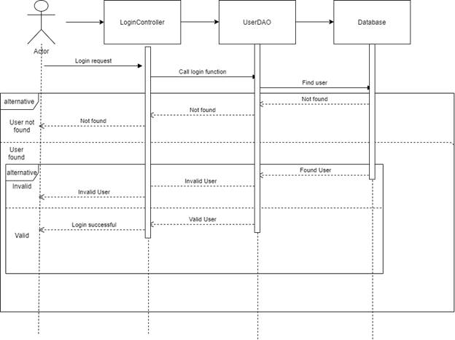

### d. Database queries

**"select * from [User] where username=? and password=?";**

## 8. Register

### a. Class Diagram

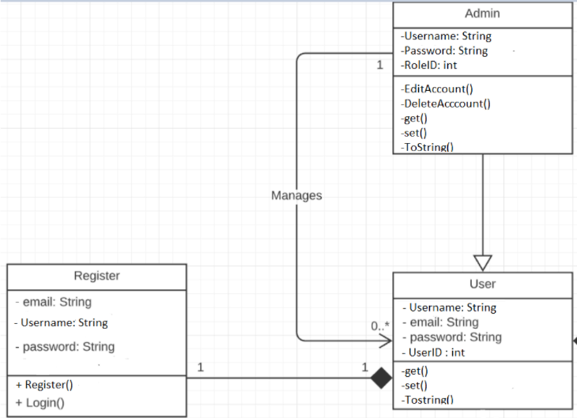

### b. Class Specifications

UserDAO

[Provide the detailed description for the class methods]

|  |  |  |
| --- | --- | --- |
| No | Method | Description |
| 01 | Register( String username,String password, String mai) | insert a new user with Name , Pass, Mail) |
| 02 | checkAccount(String xName) | - check if the username is already exist  - return null |

UserController

Class Methods

[Provide the detailed description for the class methods]

|  |  |  |
| --- | --- | --- |
| No | Method | Description |
| 01 | processRequest | get all new information from user Form and update the database |

### 

### c. Sequence Diagram(s)

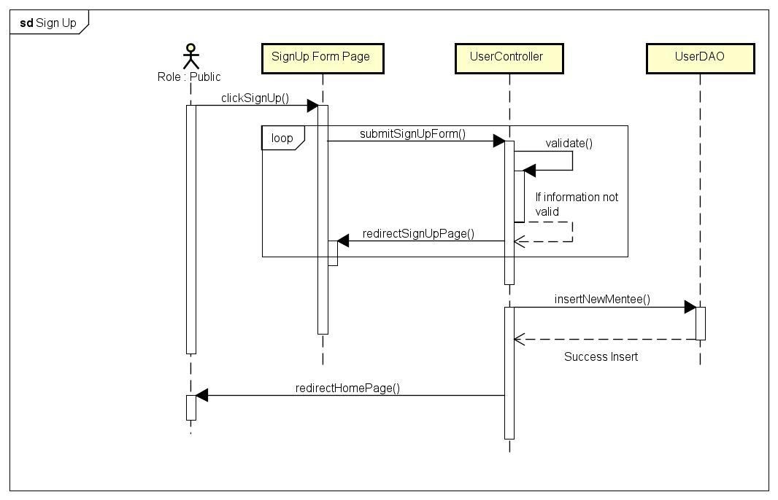

### d. Database queries

**+insert into [User] value(?,?,?,?,3,1)**

## 9. View User List

### a. Class Diagram

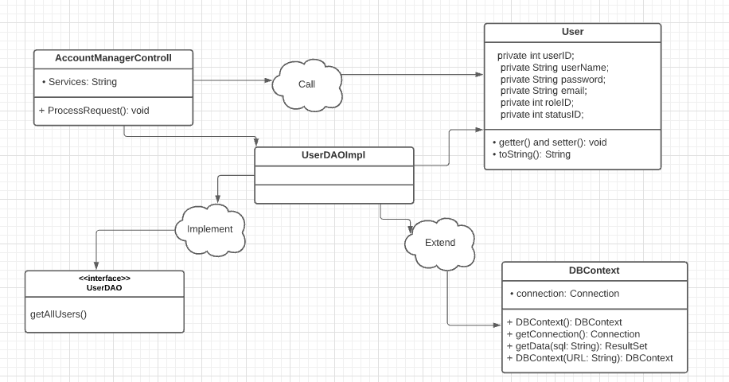

### b. Class Specifications

* AccountManagerControll:

|  |  |  |
| --- | --- | --- |
| No | Method | Description |
| 01 | processRequest() | - *Return: Null*  - *Parameter: HttpServletRequest request, HttpServletResponse response*  - *Receive request from client and process data with Database, then return a list containing all users and put that data to jsp page* |

* UserDAO:

|  |  |  |
| --- | --- | --- |
| No | Method | Description |
| 01 | getAllUsers() | - Return: List<User>  - Parameter: No  - Get all the users in the database and return a list of users |

### c. Sequence Diagram(s)

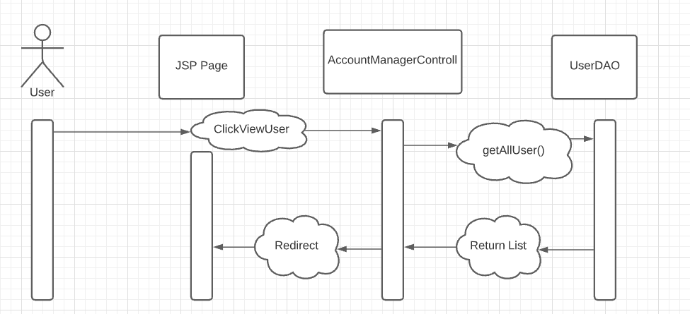

### d. Database queries

* select * from Users

## 10. Edit User

### a. Class Diagram

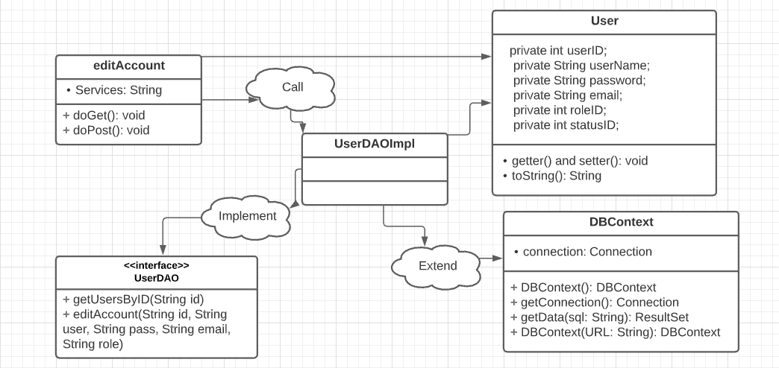

### b. Class Specifications

* editAccount:

|  |  |  |
| --- | --- | --- |
| No | Method | Description |
| 01 | processRequest() | - *Return: Null*  - *Input: Service (createUser)*  - *Get data from Form in AccountManager.JSP page and process them, and update that User into DB and direct to the AccountManager.JSP page* |
| 02 | doGet() | * Get user by UserID from the database, and load current his/her information to textbox |
| 03 | doPost() | * Update User’s information in to database |

* UserDAO:

|  |  |  |
| --- | --- | --- |
| No | Method | Description |
| 01 | editAccount | - *Return: new User*  - *Input: All properties of entity User*  - *Update the User entered on AccountManager.JSP page to database* |
| 02 | getUsersByID | - *Return: ‘A user’ or ‘Null’*  - *Input: UserID*  - *Find User by UserID* |

### c. Sequence Diagram(s)

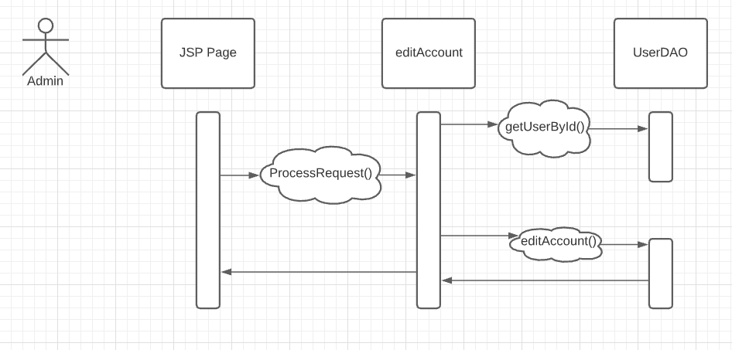

### d. Database queries

* select * from Users where UserID = ?
* UPDATE Users SET Username = ?, Password = ?, email = ?, RoleID = ? WHERE UserID = ?

## 11. Delete User

### a. Class Diagram

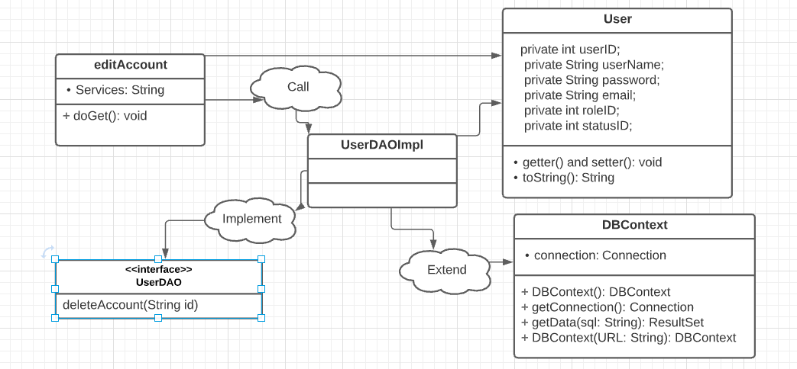

### b. Class Specifications

* deleteAccount:

|  |  |  |
| --- | --- | --- |
| No | Method | Description |
| 01 | processRequest() | - *Return: Null*  - *Input: Service (deleteUser)*  - *Get data from Form in AccountManager.JSP page and process them, and delete that User into DB and direct to the AccountManager.JSP page* |

* UserDAO:

|  |  |  |
| --- | --- | --- |
| No | Method | Description |
| 01 | deleteAccount | - *Return: New list of user*  - *Input: UserID of a user*  - *Delete the User entered on AccountManager.JSP page to database* |

### c. Sequence Diagram(s)

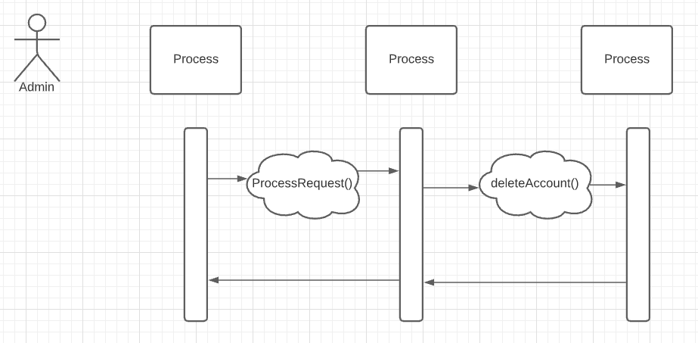

### d. Database queries

* delete from Users where UserID = ?

## 12. Customers List[Seller]

### a. Class Diagram

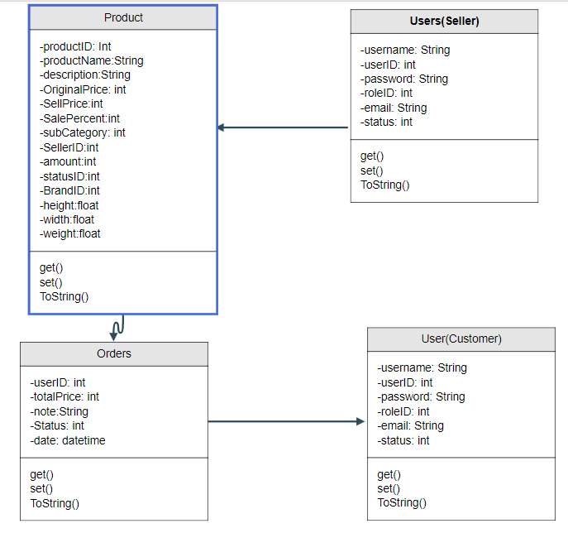

### b. Class Specifications

|  |  |  |
| --- | --- | --- |
| No | Method | Description |
| 01 | getUserByUsername() | *get user from dtb by username* |

### c. Sequence Diagram(s)

### d. Database queries

## 13. Add Ship Information

### a. Class Diagram

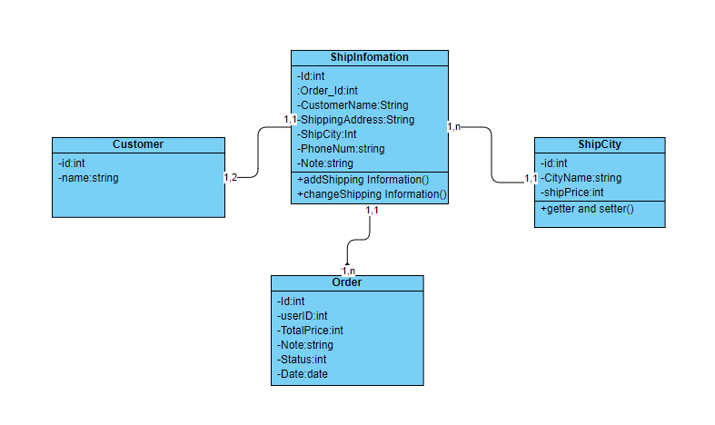

### b. Class Specifications

Ship Information Class

|  |  |  |
| --- | --- | --- |
| **No** | **Method** | **Description** |
| *01* | *addShipping information()* | *Add New Shipping information for account* |

### c. Sequence Diagram(s)

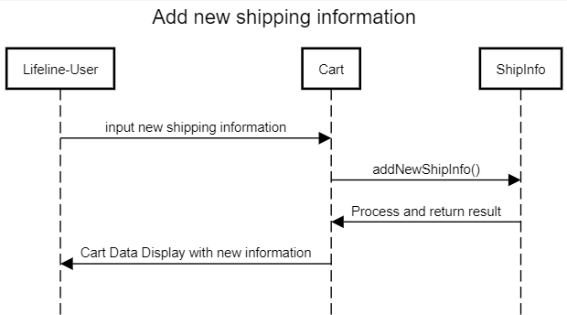Prod. Database queries

INSERT INTO dbo.ShipInfo(order_id,customerName,shippingAddress,ShipCity,PhoneNum,Note) VALUES(?,?,?,?,?,?)

## 14. Change Ship Information

### a. Class Diagram



### b. Class Specifications

Ship Information Class

|  |  |  |
| --- | --- | --- |
| **No** | **Method** | **Description** |
| *01* | *changeShipping information()* | *Change existing shipping information for current order* |

### c. Sequence Diagram(s)

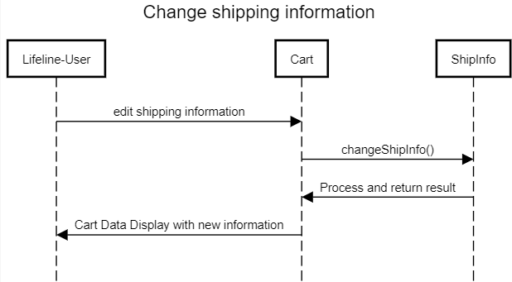

### d. Database queries

Update dbo.ShipInfomation

SET CustomerName=?,ShippingAddress=?,ShipCity=?,PhoneNum=?,Note=?

Where orderID = ?

15. Reset Password

### a. Class Diagram

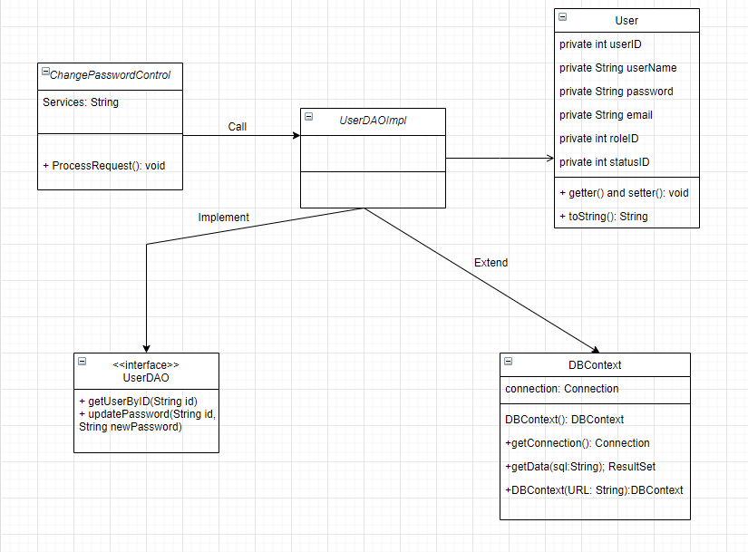

### b. Class Specifications

* ResetPasswordControl:

|  |  |  |
| --- | --- | --- |
| No | Method | Description |
| 01 | processRequest() | - *Return: Null*  **- Parameter: HttpServletRequest request, HttpServletResponse response** |

* UserDAO:

|  |  |  |
| --- | --- | --- |
| No | Method | Description |
| 01 | getUsersByID() | - *Return: ‘A user’ or ‘Null’*  - *Input: UserID*  - *Find User by UserID* |
| 02 | updatePassword() | - *Return: void*  - Parameter: input string  - *Input: UserID, newPassword*  - *Update this new password into database* |

### c. Sequence Diagram(s)

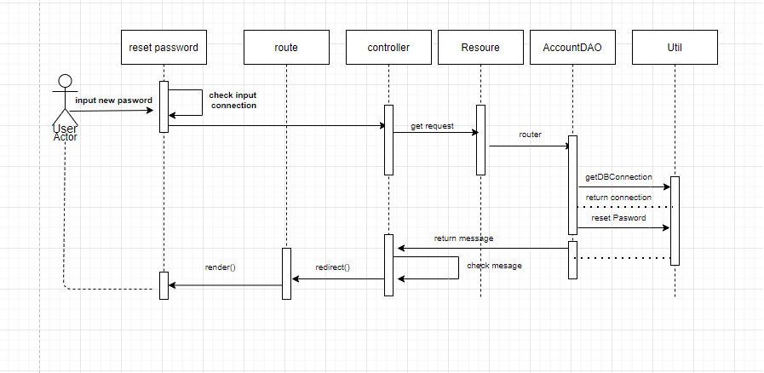

**d. Database queries**

* select * from Users where UserID = ?
* UPDATE Users SET Password = ? WHERE UserID = ?

## 16. Change Password

### a. Class Diagram

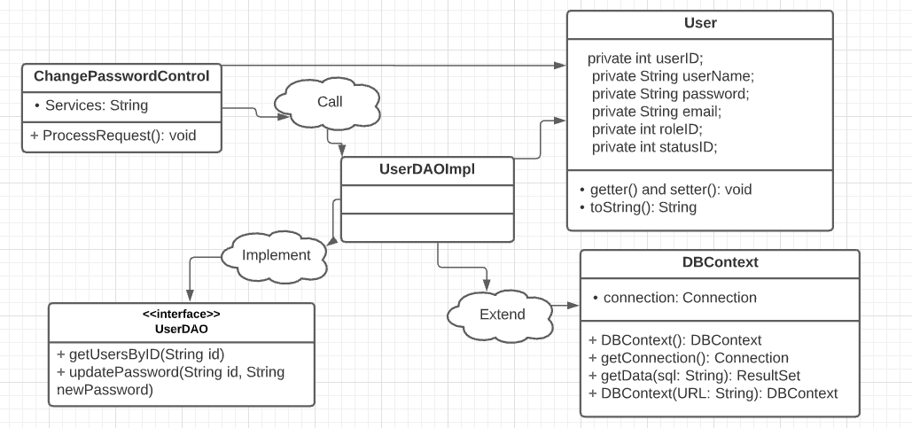

### b. Class Specifications

* ChangePasswordControl:

|  |  |  |
| --- | --- | --- |
| No | Method | Description |
| 01 | processRequest() | - *Return: Null*  **- Parameter: HttpServletRequest request, HttpServletResponse response** |

* UserDAO:

|  |  |  |
| --- | --- | --- |
| No | Method | Description |
| 01 | getUsersByID() | - *Return: ‘A user’ or ‘Null’*  - *Input: UserID*  - *Find User by UserID* |
| 02 | updatePassword() | - *Return: void*  - Parameter: input string  - *Input: UserID, newPassword*  - *Update this new password into database* |

### c. Sequence Diagram(s)

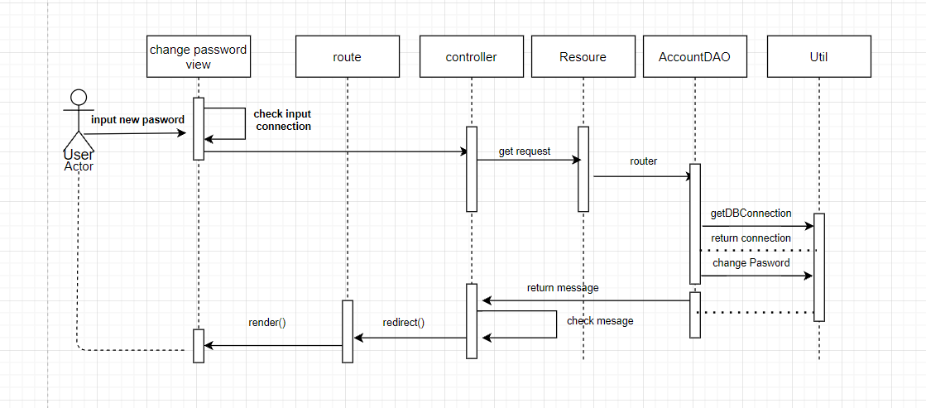

### d. Database queries

* select * from Users where UserID = ?
* UPDATE Users SET Password = ? WHERE UserID = ?

## 17. User Profile

### a. Class Diagram

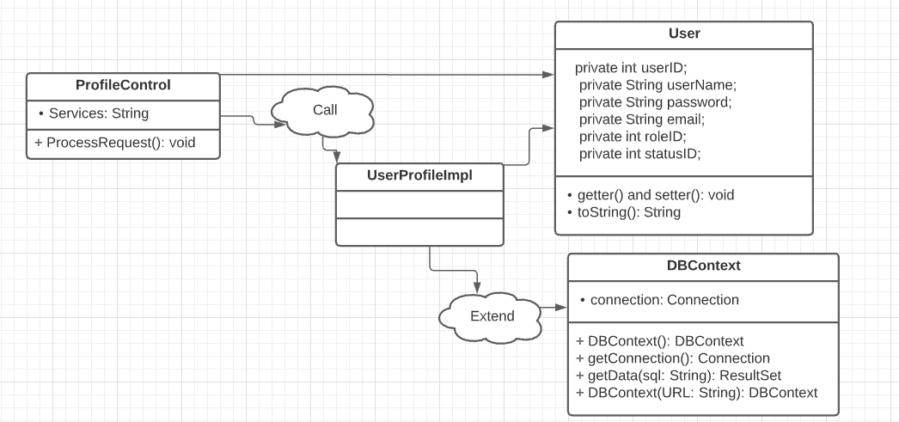

### b. Class Specifications

* ProfileControll:

|  |  |  |
| --- | --- | --- |
| No | Method | Description |
| 01 | processRequest() | get all user information from the database |

### c. Sequence Diagram(s)

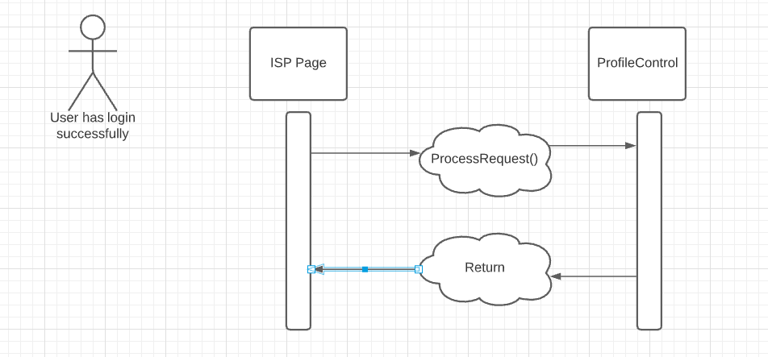

## 18. My Orders

### a. Class Diagram

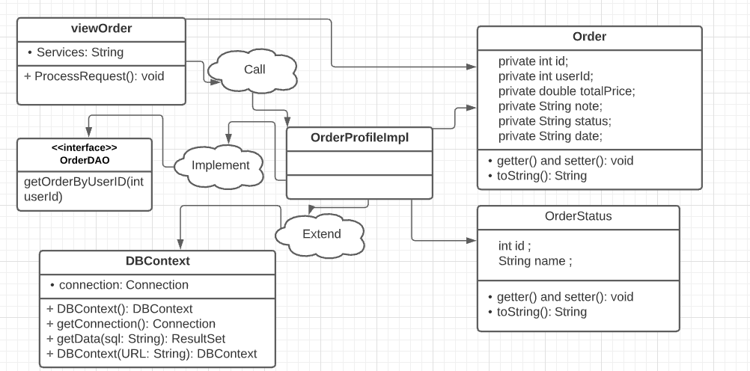

### b. Class Specifications

* viewOrderr:

|  |  |  |
| --- | --- | --- |
| No | Method | Description |
| 01 | processRequest() | - *Return: Null*  - *Parameter: HttpServletRequest request, HttpServletResponse response*  - *Receive request from client and process data with Database, then return a list containing all orders and put that data to jsp page* |

* OrderDAO:

|  |  |  |
| --- | --- | --- |
| No | Method | Description |
| 01 | getAllUsers() | - *Return: List<Order>*  - ***Parameter: UserID***  - *Get all the orders of a user in the database and return a list of orders* |

### c. Sequence Diagram(s)

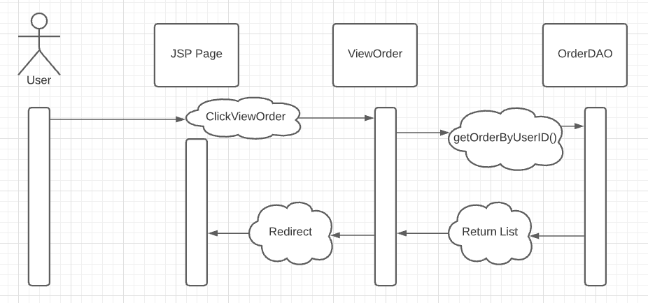

**d. Database queries**

* SELECT o.ID, o.UserID, o.TotalPrice, o.Note, os.Name, o.DayBuy FROM Orders o INNER JOIN Order_Status os ON o.Status = os.ID WHERE o.UserId = ?

## 19. Order Information

### a. Class Diagram

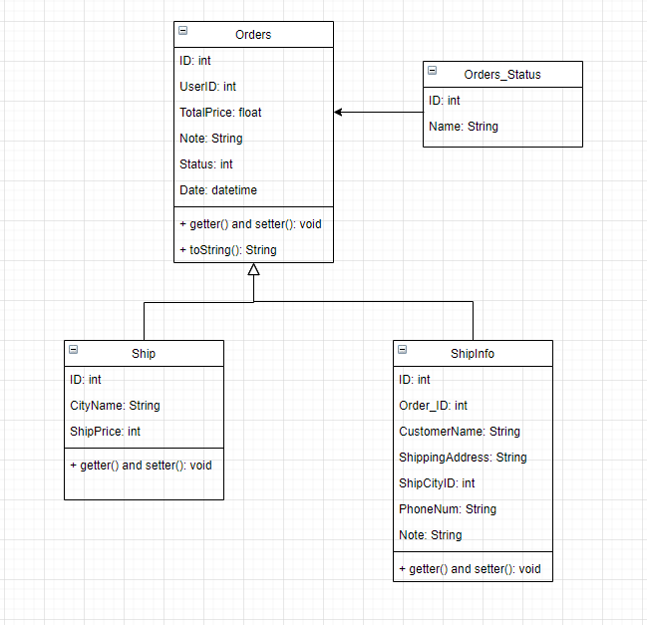

**b. Class Specifications**

* viewOrderr:

|  |  |  |
| --- | --- | --- |
| No | Method | Description |
| 01 | processRequest() | - *Return: Null*  - *Parameter: HttpServletRequest request, HttpServletResponse response*  - *Receive request from client and process data with Database, then return a list containing all orders and put that data to jsp page* |

* OrderDAO:

|  |  |  |
| --- | --- | --- |
| No | Method | Description |
| 01 | getAllUsers() | - *Return: List<Order>*  - ***Parameter: UserID***  - *Get all the orders of a user in the database and return a list of orders* |

### c. Sequence Diagram(s)



### d. Database queries

SELECT o.ID, o.UserID, o.TotalPrice, o.Note, os.Name, o.DayBuy FROM Orders o INNER JOIN Order_Status os ON o.Status = os.ID WHERE o.UserId = ?

**20. View Product List**

**a. Class Diagram**

**b. Class Specifications**

**c. Sequence Diagram(s)**

**d. Database queries**

**21. Orders List**

**a. Class Diagram**

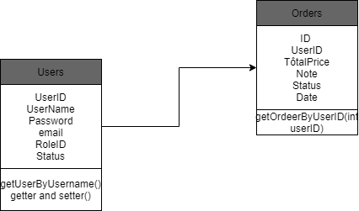

**b. Class Specifications**

**Dashboard**

|  |  |  |
| --- | --- | --- |
| No | Method | Description |
| 01 | doget() | - *Parameter: HttpServletRequest request, HttpServletResponse response*  - *Receive request from client and process data with Database, then return a list containing orders by list Product and put that data to jsp page* |

**OrderDAO**

|  |  |  |
| --- | --- | --- |
| No | Method | Description |
| 01 | getOrderByUserID(int userId) | - *Return: list Order*  - *Parameter:* userID  - Get list Order by userID |

**c. Sequence Diagram(s)**

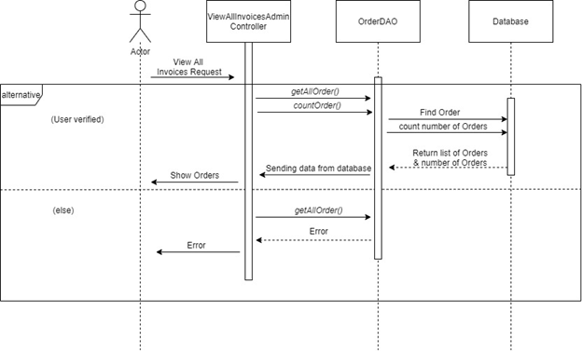

### d. Database queries

* SELECT o.ID, o.UserID, o.TotalPrice, o.Note, os.Name, o.DayBuy FROM Orders o INNER JOIN Order_Status os

ON o.Status = os.ID WHERE o.UserId = ?

## 22. Order Details

### a. Class Diagram

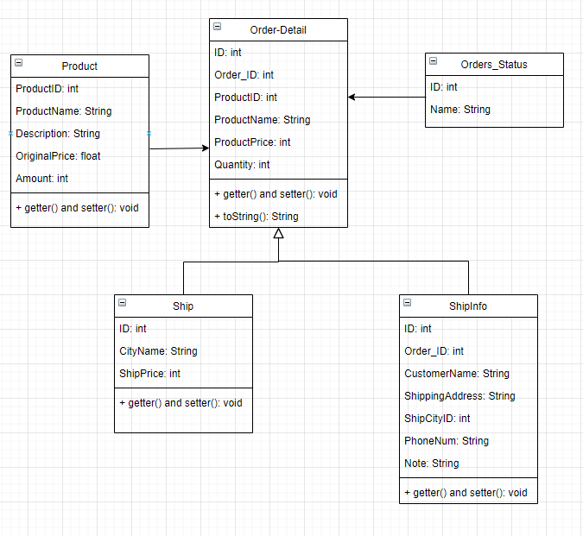

### b. Class Specifications

* viewOrder Details:

|  |  |  |
| --- | --- | --- |
| No | Method | Description |
| 01 | processRequest() | - *Return: Null*  - *Parameter: HttpServletRequest request, HttpServletResponse response*  - *Receive request from client and process data with Database, then return a list containing all orders and put that data to jsp page* |

* OrderDAO:

|  |  |  |
| --- | --- | --- |
| No | Method | Description |
| 01 | getAllUsers() | - *Return: List<Order>*  - ***Parameter: UserID***  - *Get all the orders of a user in the database and return a list of orders* |

### c. Sequence Diagram(s)

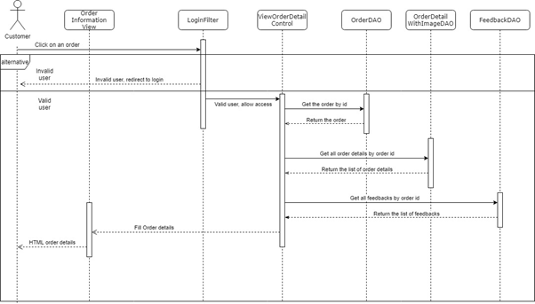

### d. Database queries

SELECT o.ID, o.Order_ID, o.ProductID, o.ProductName, o.ProductPrice os.Name, o.DayBuy FROM Orders o INNER JOIN Order_Status os ON o.Status = os.ID WHERE o.UserId = ?

## 23. View Feedback

### a. Class Diagram

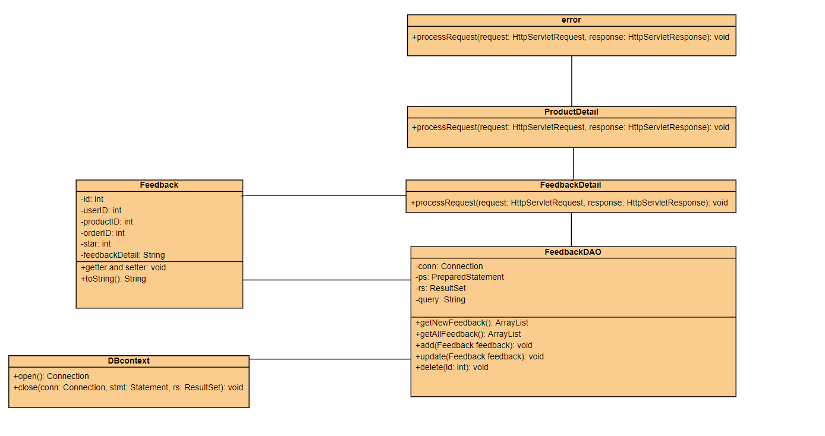

### b. Class Specifications

* FeedbackDetail class

|  |  |  |
| --- | --- | --- |
| **No** | **Method** | **Description** |
| *01* | *processRequest()* | *get blog detail from the database to display on ProductDetail.jsp* |

* FeedbackDAO class

|  |  |  |
| --- | --- | --- |
| **No** | **Method** | **Description** |
| *01* | *getNewFeedback()* | *Return: top 5 newest Feedback from database* |
| *03* | *getAllFeedback (int id)* | *Return: All Feedback of a product in database*  *input: id* |
| *04* | *add(Feedback feedback)* | *Add feedback with detail entered in addFeedback.jsp page*  *Return: null*  *Input: feedback* |
| *05* | *update(Feedback feedback)* | *Update feedback with detail entered in updateFeedback.jsp page*  *Return: null*  *Input: feedback* |
| *06* | *delete(int id)* | *Update feedback with id entered in updateFeedback.jsp*  *Return: null*  *Input: id* |

### c. Sequence Diagram(s)

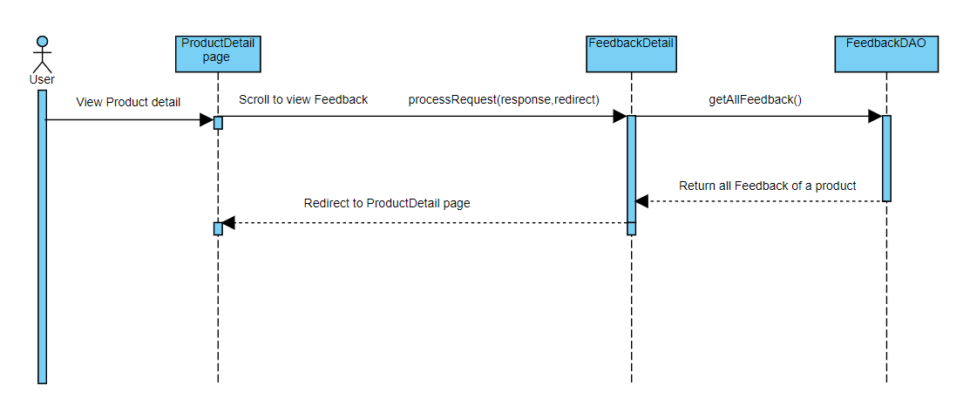

### d. Database queries

Select * from Feedback where productID=?

## 24. Send Feedback

### a. Class Diagram

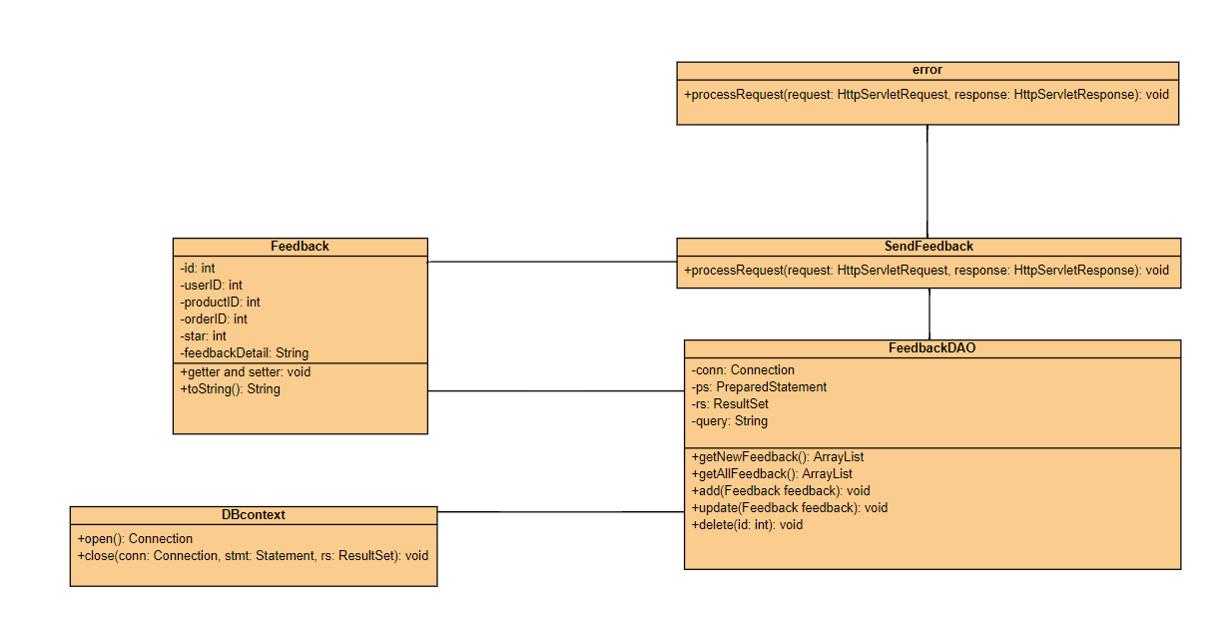

### b. Class Specifications

* SendFeedback class

|  |  |  |
| --- | --- | --- |
| **No** | **Method** | **Description** |
| *01* | *processRequest()* | *get Form Feedback to display on SendFeedback.jsp* |

* FeedbackDAO class

|  |  |  |
| --- | --- | --- |
| **No** | **Method** | **Description** |
| *01* | *getNewFeedback()* | *Return: top 5 newest Feedback from database* |
| *03* | *getAllFeedback (int id)* | *Return: All Feedback of a product in database*  *input: id* |
| *04* | *add(Feedback feedback)* | *Add feedback with detail entered in addFeedback.jsp page*  *Return: null*  *Input: feedback* |
| *05* | *update(Feedback feedback)* | *Update feedback with detail entered in updateFeedback.jsp page*  *Return: null*  *Input: feedback* |
| *06* | *delete(int id)* | *Update feedback with id entered in updateFeedback.jsp*  *Return: null*  *Input: id* |

### c. Sequence Diagram(s)

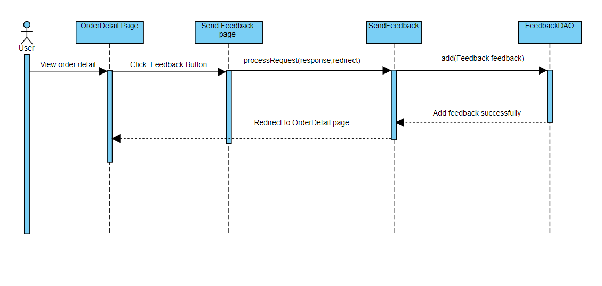

### d. Database queries

Insert into Feedback value (?,?,?,?,?)

## 25. Blogs List

### a. Class Diagram

### b. Class Specifications

* BlogList class

|  |  |  |
| --- | --- | --- |
| **No** | **Method** | **Description** |
| *01* | *processRequest()* | *get blog list from the database to display on BlogList.jsp* |

* BlogDAO class

|  |  |  |
| --- | --- | --- |
| **No** | **Method** | **Description** |
| *01* | *getBlogByID(int id)* | *Return: Blog Detail where blog id contain parameter*  *Input: ID of blog* |
| *02* | *getHotBlogs()* | *Return: top 3 newest blog from database* |
| *03* | *getAllBlog()* | *Return: All blog in database* |
| *04* | *add(String author, String title, String content, String imageLink)* | *Add blog with detail entered in addBlog.jsp page*  *Return: null*  *Input: author, title, content, imageLink* |
| *05* | *update(String author, String title, String content, String imageLink, String id)* | *Update blog with detail entered in updateBlog.jsp page*  *Return: null*  *Input: author, title, content, imageLink, id* |
| *06* | *delete(int id)* | *Update blog with id entered in blogManage.jsp*  *Return: null*  *Input: id* |

### c. Sequence Diagram(s)

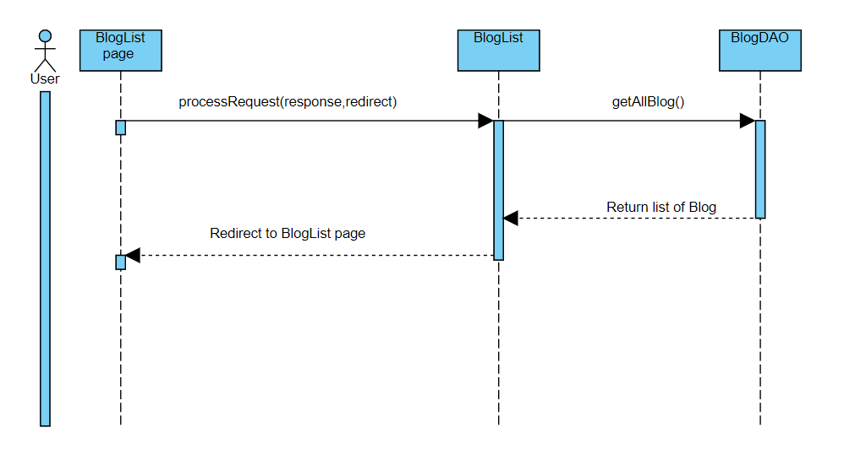

### d. Database queries

Select * from Blog desc

## 26. Blog Details

### a. Class Diagram

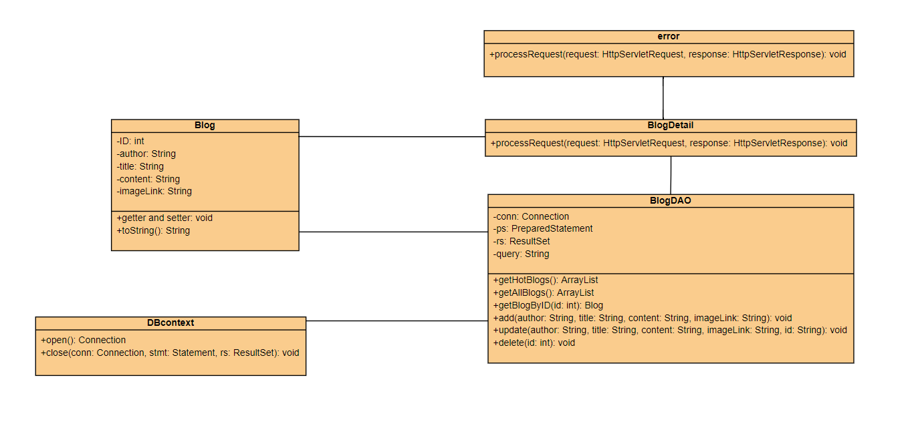

### b. Class Specifications

* BlogDetail class

|  |  |  |
| --- | --- | --- |
| **No** | **Method** | **Description** |
| *01* | *processRequest()* | *get blog detail from the database to display on BlogDetail.jsp* |

* BlogDAO class

|  |  |  |
| --- | --- | --- |
| **No** | **Method** | **Description** |
| *01* | *getBlogByID(int id)* | *Return: Blog Detail where blog id contain parameter*  *Input: ID of blog* |
| *02* | *getHotBlogs()* | *Return: top 3 newest blog from database* |
| *03* | *getAllBlog()* | *Return: All blog in database* |
| *04* | *add(String author, String title, String content, String imageLink)* | *Add blog with detail entered in addBlog.jsp page*  *Return: null*  *Input: author, title, content, imageLink* |
| *05* | *update(String author, String title, String content, String imageLink, String id)* | *Update blog with detail entered in updateBlog.jsp page*  *Return: null*  *Input: author, title, content, imageLink, id* |
| *06* | *delete(int id)* | *Update blog with id entered in blogManage.jsp*  *Return: null*  *Input: id* |

### c. Sequence Diagram(s)

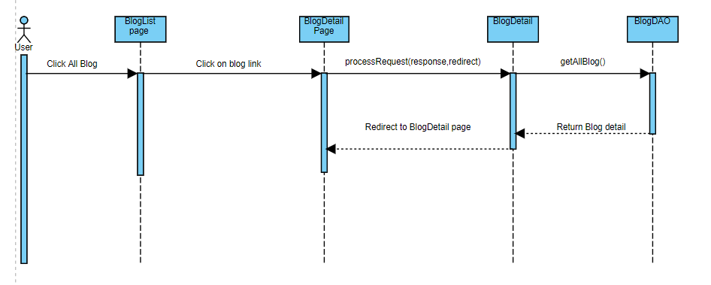

### d. Database queries

SELECT * FROM Blog WHERE ID = ?

## 27. Blog Management

### a. Class Diagram

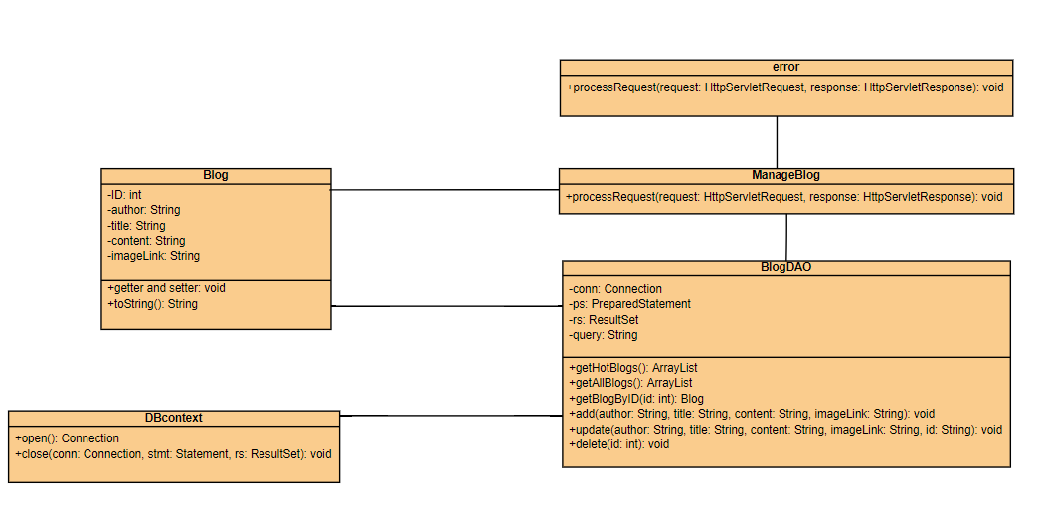

### b. Class Specifications

* ManageBlog class

|  |  |  |
| --- | --- | --- |
| **No** | **Method** | **Description** |
| *01* | *processRequest()* | *get blog detail from the database to display on ManageBlog.jsp* |

* BlogDAO class

|  |  |  |
| --- | --- | --- |
| **No** | **Method** | **Description** |
| *01* | *getBlogByID(int id)* | *Return: Blog Detail where blog id contain parameter*  *Input: ID of blog* |
| *02* | *getHotBlogs()* | *Return: top 3 newest blog from database* |
| *03* | *getAllBlog()* | *Return: All blog in database* |
| *04* | *add(String author, String title, String content, String imageLink)* | *Add blog with detail entered in addBlog.jsp page*  *Return: null*  *Input: author, title, content, imageLink* |
| *05* | *update(String author, String title, String content, String imageLink, String id)* | *Update blog with detail entered in updateBlog.jsp page*  *Return: null*  *Input: author, title, content, imageLink, id* |
| *06* | *delete(int id)* | *Update blog with id entered in blogManage.jsp*  *Return: null*  *Input: id* |

### c. Sequence Diagram(s)

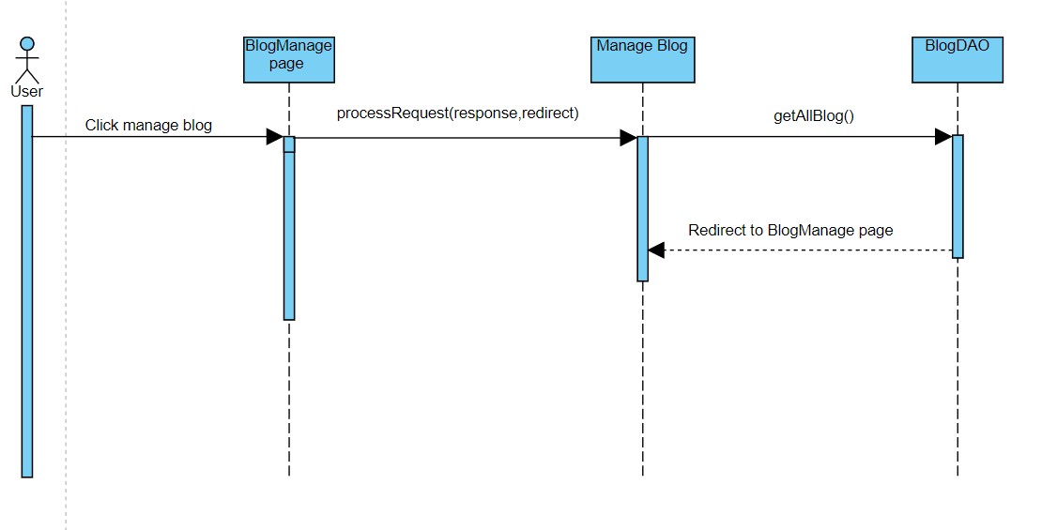

### d. Database queries

Select * from blog

## 28. View Notification

### a. Class Diagram

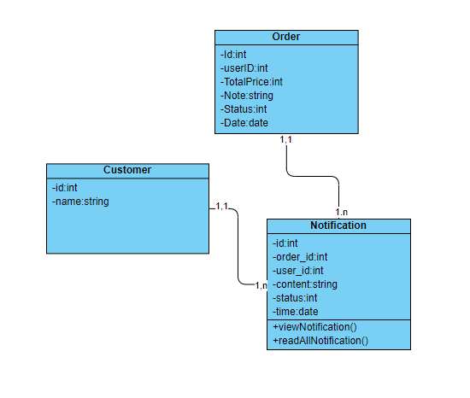

### b. Class Specifications

Notification class

|  |  |  |
| --- | --- | --- |
| **No** | **Method** | **Description** |
| *01* | *viewNotification()* | *get all notification from database for a user* |

### c. Sequence Diagram(s)

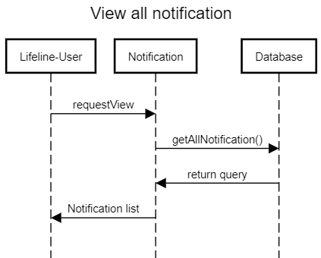

### d. Database queries

SELECT * from dbo.Notification where user_id = ?

## 29. Mark as Read

### a. Class Diagram



### b. Class Specifications

Notification class

|  |  |  |
| --- | --- | --- |
| **No** | **Method** | **Description** |
| *01* | *readAllNotification()* | *mark all notification as read* |

### c. Sequence Diagram(s)

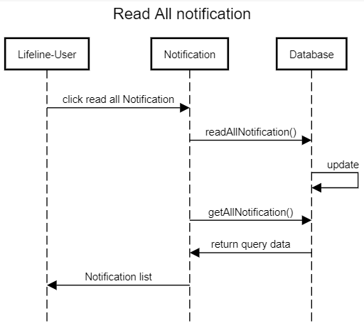

### d. Database queries

Update dbo.Notification

set status=1

where user_id=?

## 30. Admin Feature

### a. Class Diagram

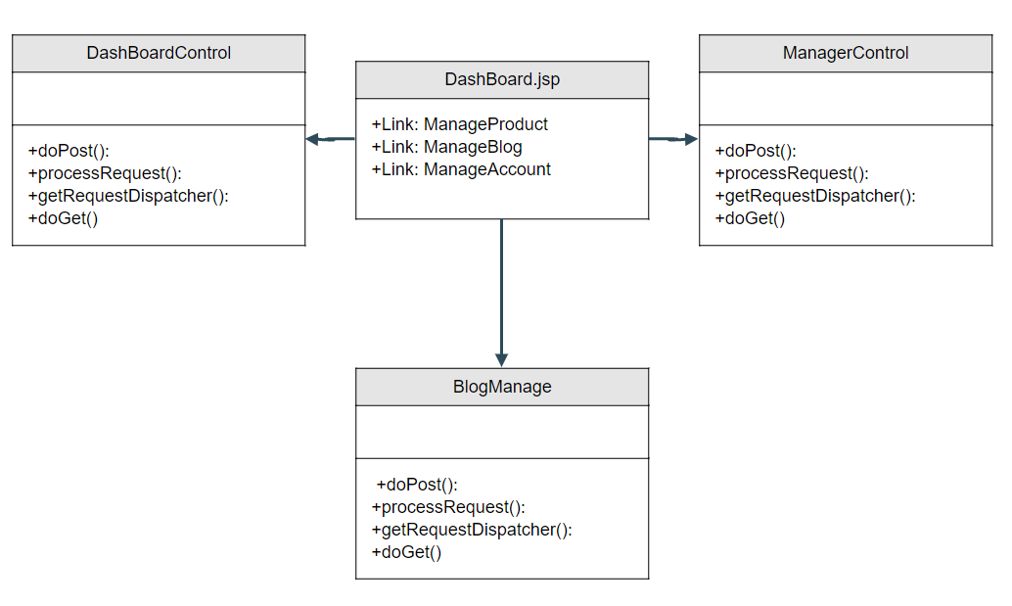

### b. Class Specifications

|  |  |  |
| --- | --- | --- |
| **No** | **Method** | **Description** |
| *01* | *processRequest()* | *get blog detail from the database to display on ManageProduct.jsp* |
| *02* | *processRequest()* | *get blog detail from the database to display on ManageAccount.jsp* |
| *03* | *processRequest()* | *get blog detail from the database to display on ManageBlog.jsp* |

### c. Sequence Diagram(s)

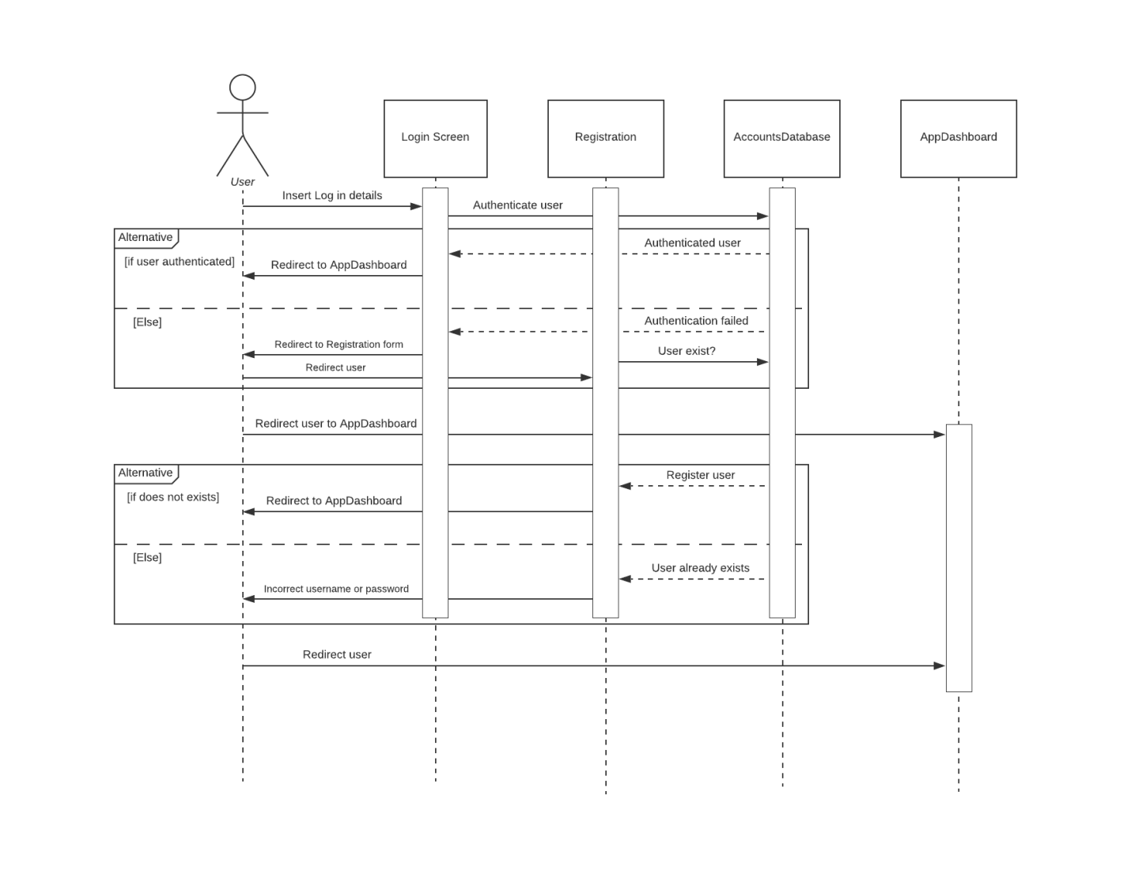

### d. Database queries

+select * from …

## 31. Add Product

### a. Class Diagram

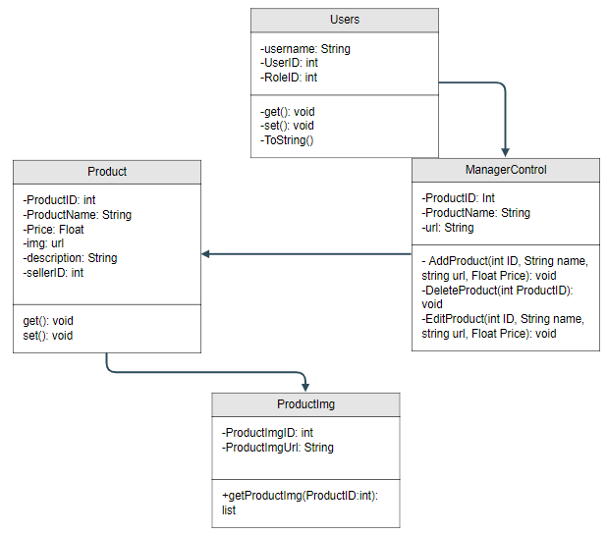

### b. Class Specifications

|  |  |  |
| --- | --- | --- |
| **No** | **Method** | **Description** |
| *01* | *processRequest()* | *AddProduct from the database to display on ManageProduct.jsp* |

### c. Sequence Diagram(s)

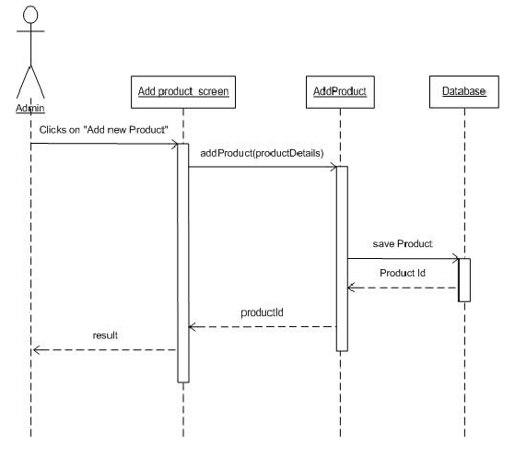

### d. Database queries

+insert into datatable (....)values (....)

## 32. Delete Product

### a. Class Diagram



### b. Class Specifications

|  |  |  |
| --- | --- | --- |
| **No** | **Method** | **Description** |
| *01* | *processRequest()* | *DeleteProduct from the database to display on ManageProduct.jsp* |

### c. Sequence Diagram(s)

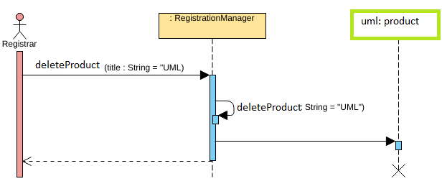

### d. Database queries

+delete from Product where ProductID = …

## 33. Edit Product

### a. Class Diagram



### b. Class Specifications

|  |  |  |
| --- | --- | --- |
| **No** | **Method** | **Description** |
| *01* | *processRequest()* | *Update from the database to display on ManageProduct.jsp* |

### c. Sequence Diagram(s)

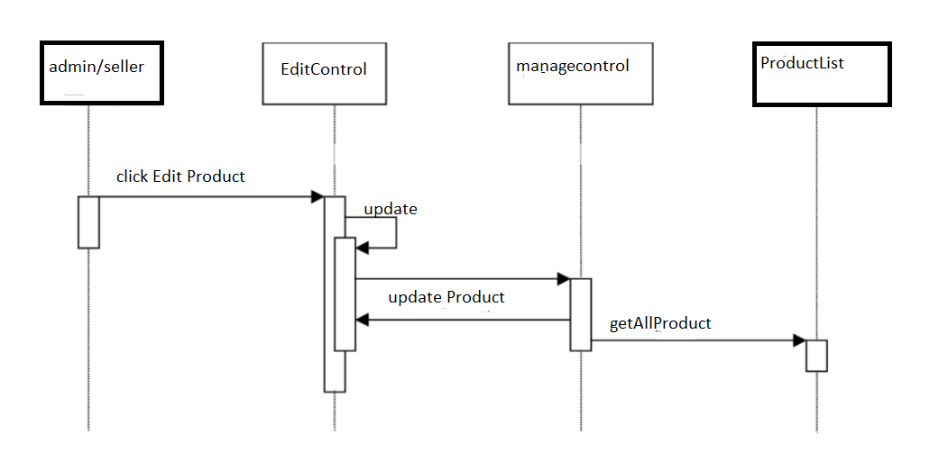

### d. Database queries

+UPDATE datatable

SET ... = '......'

WHERE …... = '.......'

## 34. Orders Dashboard

**a. Class Diagram**

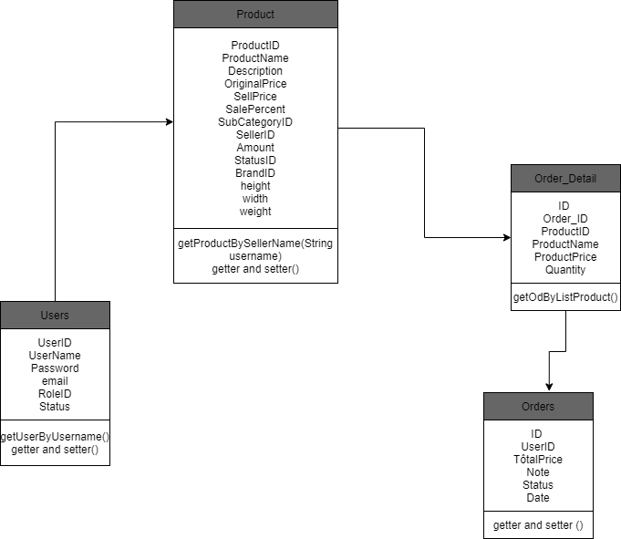

**b. Class Specifications**

**Dashboard**

|  |  |  |
| --- | --- | --- |
| No | Method | Description |
| 01 | doget() | -  - *Parameter: HttpServletRequest request, HttpServletResponse response*  - *Receive request from client and process data with Database, then return a list containing orders by list Product and put that data to jsp page* |

**Product DAO**

|  |  |  |
| --- | --- | --- |
| No | Method | Description |
| 01 | getProductBySellerName(String username) | - *Return: listProduct*  - *Parameter: String username*  - Get list product by sellerID |

**OrderDAO**

|  |  |  |
| --- | --- | --- |
| No | Method | Description |
| 01 | getOdByListProduct(ArrayList<Product> listP) | - *Return: list Order*  - *Parameter:* ArrayList<Product> listP  - Get list Order by ProductID |

**c. Sequence Diagram(s)**

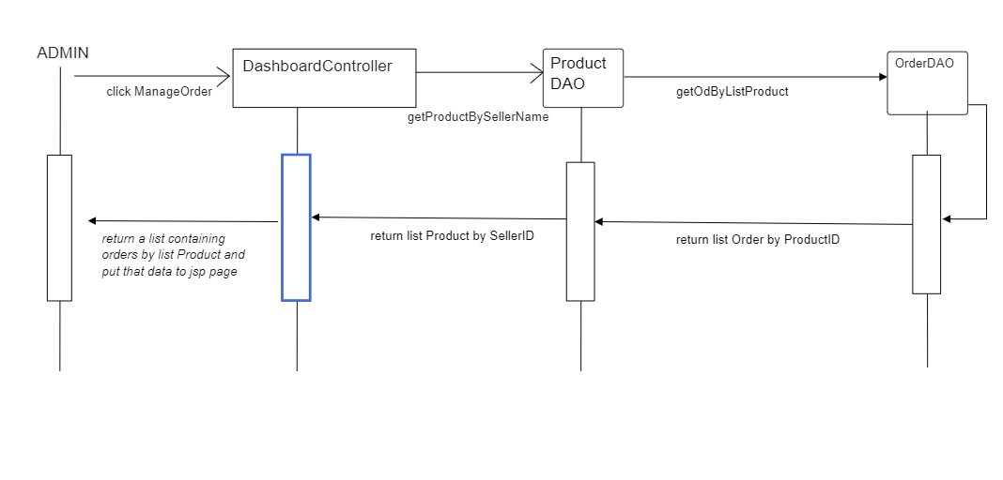

### d. Database queries

* **select * from Users where Username = ?**
* **select p.ProductID , ProductName , Description , OriginalPrice , SellPrice , SalePercent , SubCategoryID , SellerID , Amount , StatusID , StatusID ,BrandID , height , width ,weight , s.ProductImgURL from Product p join ProductImg s**

**on p.ProductID = s.ProductID where p.SellerID = (select UserID from Users where Username = ? )**

* **select o.ID , o.UserID , o.TotalPrice , o.Note , o.Status , o.Date , d.Order_ID , d.ProductID , d.ProductName , d.ProductPrice ,d.ProductPrice , d.Quantity from Orders o**

**join Order_Detail d on d.Order_ID = o.ID where ProductID = ?**

## 35. PostDetail

**a.class diagram**

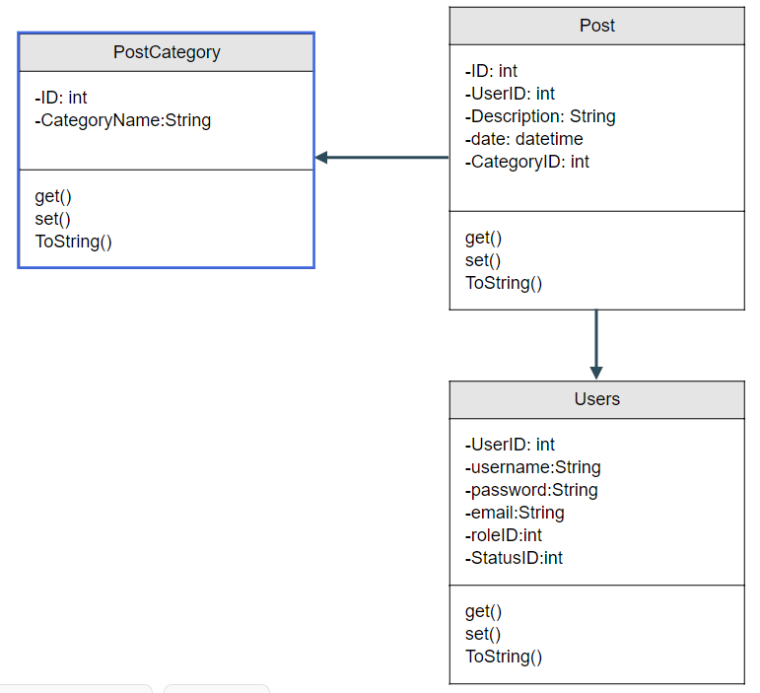

### b. Class Specifications

#### PostControl Class: The doGet function is used to get the ID of the post and then use the doPost function to edit the product

|  |  |  |
| --- | --- | --- |
| **No** | **Method** | **Description** |
| **1** | **processRequest()** | **Nothing** |
| **2** | **doGet()** | **Get ID of post and push ID, title, description, imageLink, Seller ID to EditBlog.jsp to edit** |
| **3** | **doPost()** | **Get ID, title, description, imageLink, userID in PostDetailjsp when changed, use edit function in postDAO to edit post and combackManageControl Class** |
| **4** | **getServletInfo()** | **Return a String containing servlet description** |

#### DeletepostControll Class: use process request function to get and delete post by ID

|  |  |  |
| --- | --- | --- |
| **No** | **Method** | **Description** |
| **1** | **processRequest()** | **Get ID of post need to Delete and use function delete in post DAO to delete post by ID and comeback Error.jsp** |
| **2** | **doGet()** | **Nothing** |
| **3** | **doPost()** | **Nothing** |
| **4** | **getServletInfo()** | **Return a String containing servlet description** |

### c. Sequence Diagram(s)

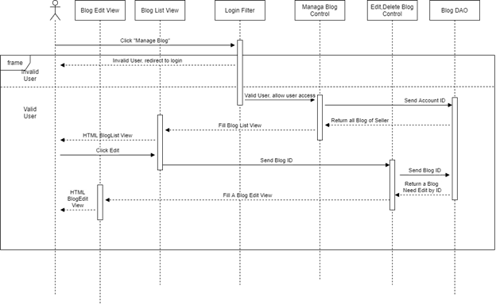

### d. Database queries

- "Delete FROM Post WHERE ID = ?"

- "Update …= ? “

- "INSERT INTO Post VALUES (?,?,?,?)"

**36. PostList**

**a.class diagram**



### b. Class Specifications

#### PostManageControl Class: This class process request for list of post create by user ID

|  |  |  |
| --- | --- | --- |
| **No** | **Method** | **Description** |
| **1** | **processRequest()** | **Select list Post of user in SQL server and return Postlist.jsp** |
| **2** | **doGet()** | **Nothing** |
| **3** | **doPost()** | **Nothing** |

**c.sequences diagram**

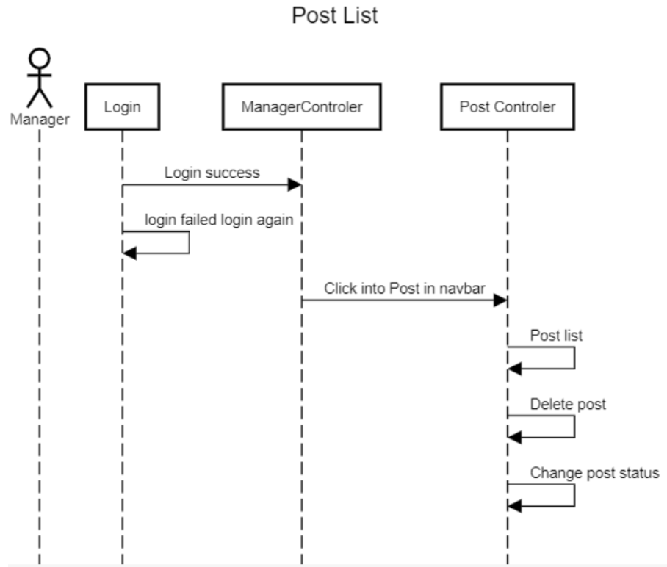

### d. Database queries

**- "SELECT * FROM Post WHERE ID = ?"**

## 

## 37. Error

### a. Class Diagram

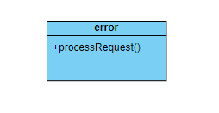

### b. Class Specifications

error Class

|  |  |  |
| --- | --- | --- |
| **No** | **Method** | **Description** |
| *01* | *processRequest()* | *Process and return error page html back to user* |

### c. Sequence Diagram(s)

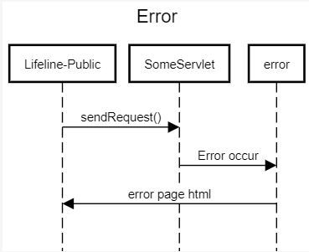

### d. Database queries

None

## 

## 38. Manage Feedback [Seller]

### a. Class Diagram

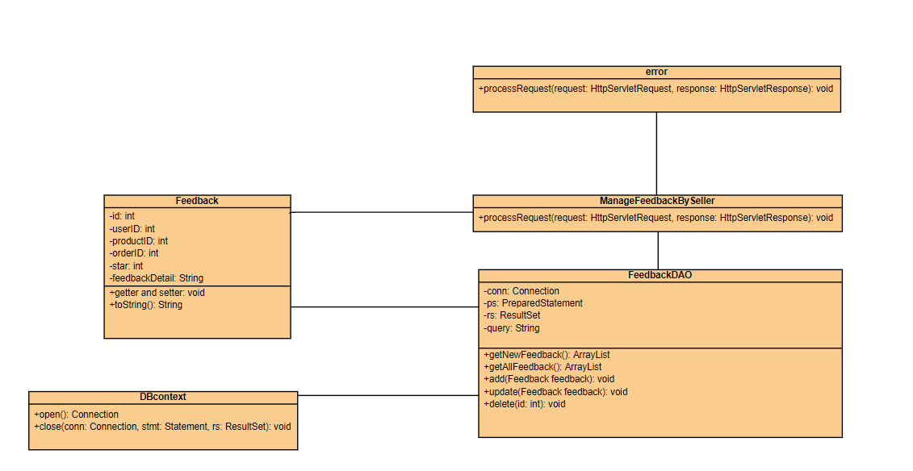

### b. Class Specifications

* ManageFeedbackBySeller class

|  |  |  |
| --- | --- | --- |
| **No** | **Method** | **Description** |
| *01* | *processRequest()* | *get Feedback by Seller to display on ManageFeedbackBySeller.jsp* |

* FeedbackDAO class

|  |  |  |
| --- | --- | --- |
| **No** | **Method** | **Description** |
| *01* | *getNewFeedback()* | *Return: top 5 newest Feedback from database* |
| *03* | *getAllFeedback (int id)* | *Return: All Feedback of a product in database*  *input: id* |
| *04* | *add(Feedback feedback)* | *Add feedback with detail entered in addFeedback.jsp page*  *Return: null*  *Input: feedback* |
| *05* | *update(Feedback feedback)* | *Update feedback with detail entered in updateFeedback.jsp page*  *Return: null*  *Input: feedback* |
| *06* | *delete(int id)* | *Update feedback with id entered in updateFeedback.jsp*  *Return: null*  *Input: id* |

### c. Sequence Diagram(s)

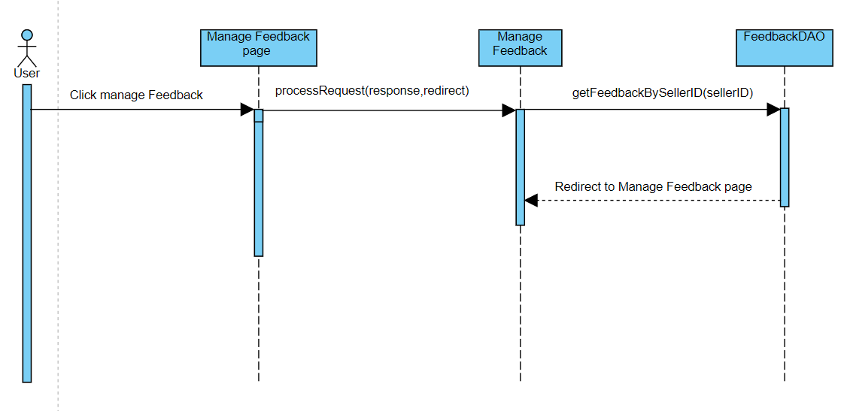

### d. Database queries

SELECT * FROM (dbo.Feedback f JOIN dbo.Product p ON p.ProductID=f.ProductID) JOIN dbo.Users u ON u.UserID=p.SellerID WHERE f.UserID=?

## 39. Manage Feedback [Customer]

### a. Class Diagram

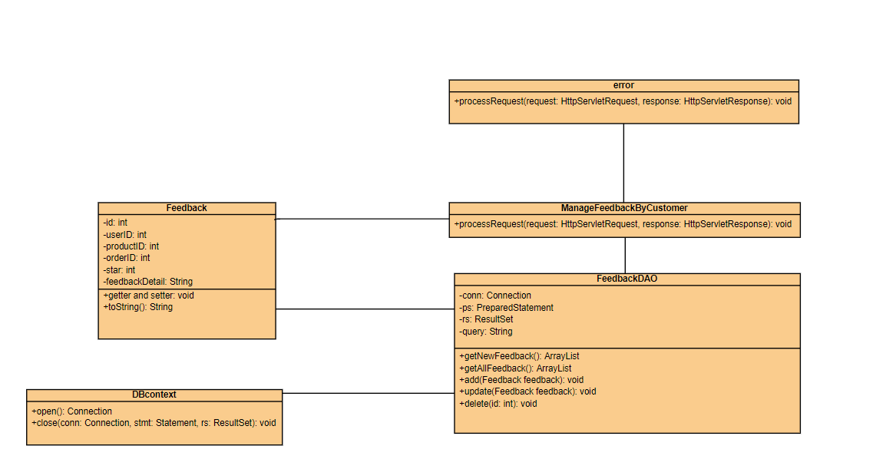

### b. Class Specifications

* ManageFeedbackBySeller class

|  |  |  |
| --- | --- | --- |
| **No** | **Method** | **Description** |
| *01* | *processRequest()* | *get Feedback by Customer to display on ManageFeedbackByCustomer.jsp* |

* FeedbackDAO class

|  |  |  |
| --- | --- | --- |
| **No** | **Method** | **Description** |
| *01* | *getNewFeedback()* | *Return: top 5 newest Feedback from database* |
| *03* | *getAllFeedback (int id)* | *Return: All Feedback of a product in database*  *input: id* |
| *04* | *add(Feedback feedback)* | *Add feedback with detail entered in addFeedback.jsp page*  *Return: null*  *Input: feedback* |
| *05* | *update(Feedback feedback)* | *Update feedback with detail entered in updateFeedback.jsp page*  *Return: null*  *Input: feedback* |
| *06* | *delete(int id)* | *Update feedback with id entered in updateFeedback.jsp*  *Return: null*  *Input: id* |

### c. Sequence Diagram(s)

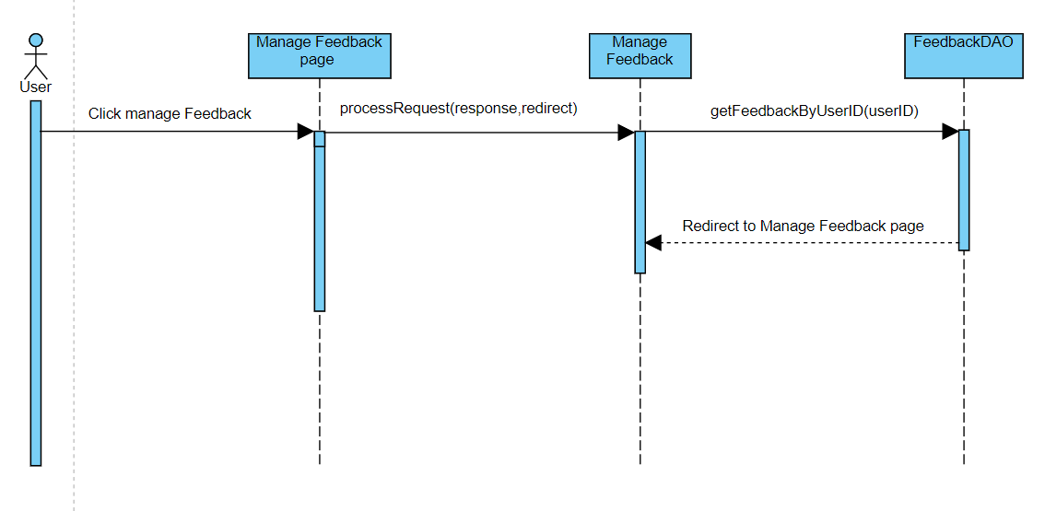

### d. Database queries

SELECT * FROM (dbo.Feedback f JOIN dbo.Product p ON p.ProductID=f.ProductID) JOIN dbo.Users u ON u.UserID=p.SellerID WHERE f.UserID=?

### 

## 40. Manage Banner

### a. Class Diagram

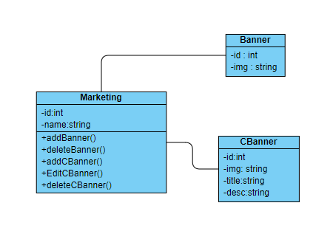

### b. Class Specifications

|  |  |  |
| --- | --- | --- |
| **No** | **Method** | **Description** |
| *01* | *addBanner()* | *add new Banner to database* |
| *02* | *deleteBanner()* | *delete Banner from database* |
| *03* | *addCBanner()* | *add new Homepage Carousel Banner* |
| *04* | *editCBanner()* | *edit existing Carousel Banner* |
| *05* | *deleteCBanner()* | *delete old Carousel Banner* |

### c. Sequence Diagram(s)

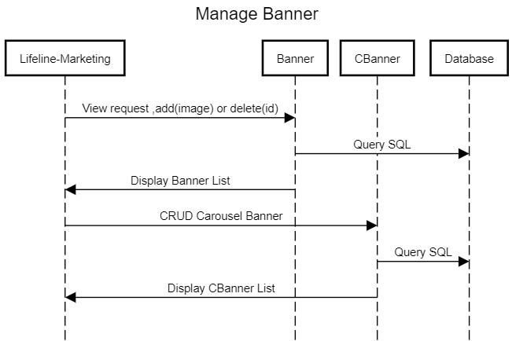

### d. Database queries

SELECT * FROM dbo.Banner WHERE ID = ?

SELECT * FROM dbo.Banner

INSERT INTO dbo.Banner VALUES ( ? )

DELETE FROM dbo.Banner WHERE ID = ?

SELECT * FROM dbo.CBanner WHERE ID = ?

SELECT * FROM dbo.CBanner

INSERT INTO dbo.CBanner VALUES ( ? , ? , ? )

UPDATE dbo.CBanner SET Img = ?,Title = ? , [desc] = ? WHERE ID = ?

DELETE FROM dbo.CBanner WHERE ID = ?

## 41. Chat

### a. Class Diagram

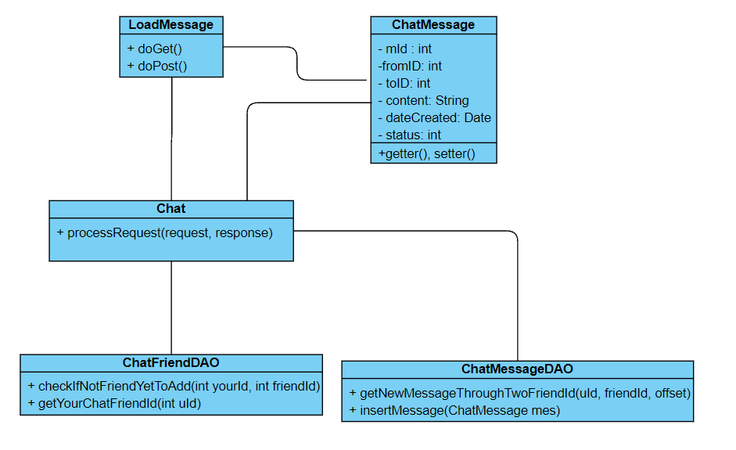

### b. Class Specifications

Chat

### 

|  |  |  |
| --- | --- | --- |
| No | Method | Description |
| 01 | processRequest(request, response) | * Press Request Statistic on header will call this controller * This class will get list of friend from data for user and send it to chatbox jsp * Will run to mentorRequestStatistic jsp with attribute data * Will throw Exception and run to error jsp if there any error |

### 

LoadMessage

|  |  |  |
| --- | --- | --- |
| No | Method | Description |
| 01 | doGet(HttpServletRequest request, HttpServletResponse response) | This get method will load new message for the user and send to ajax and load newly inserted messages if they have not been shown |
| 02 | doPost(HttpServletRequest request, HttpServletResponse response) | This post method will get message which user post and insert it into database |

### 

ChatFriendDAO

### 

|  |  |  |
| --- | --- | --- |
| No | Method | Description |
| 01 | checkIfNotFriendYetToAdd(int yourId, int friendId) | * This method will check two argument id if they are not friend yet, if not it will add into ChatFriend table) * param: yourId (your id) * friendId (friend id) * return: int (1 if add chat friend success) * throws Exception |
| 02 | getYourChatFriendId(int uId) | * This method will get all your chat friend id from database * param: uId (your id) * return: ArrayList<Integer> (list of friend id) * throws Exception |

### 

ChatMessageDAO

### 

|  |  |  |
| --- | --- | --- |
| No | Method | Description |
| 01 | getNewMessageThroughTwoFriendId(uId, friendId, offset) | * This method will ignore some first messages and load new message between two friend * param: uId (your id) * friendId (friend id) * offset (the number of message loaded and not need loaded again) * return: ArrayList<ChatMessage> * throws Exception |
| 02 | insertMessage(ChatMessage mes) | * This method will insert new message into database * param: mess( ChatMessage object ) * return: int (1 if add mess success) * throws Exception |

### c. Sequence Diagram

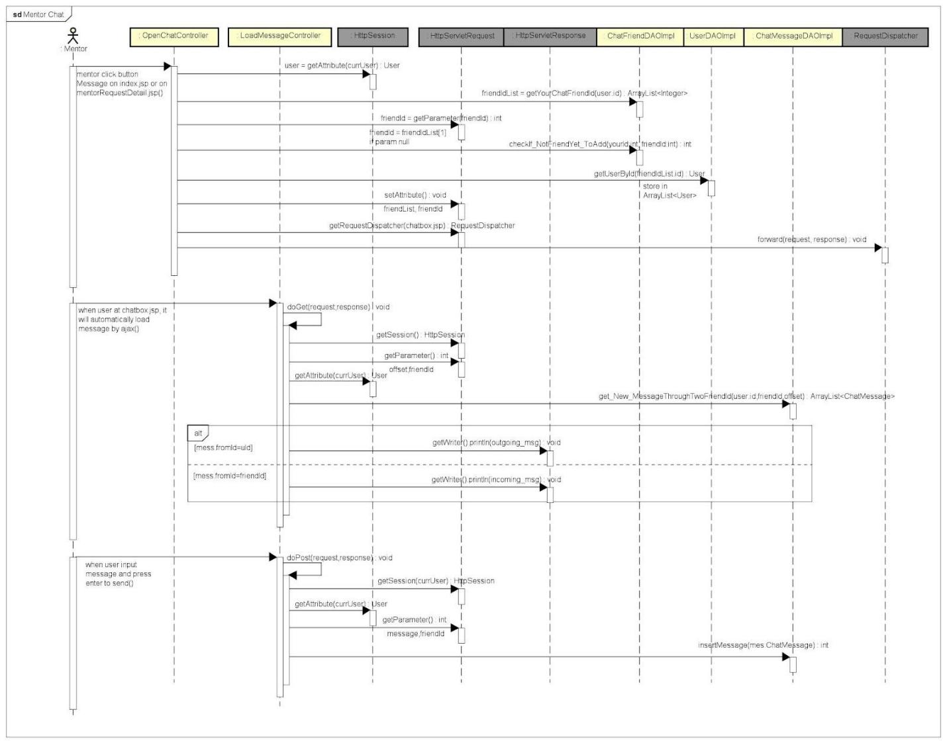

## 43. Marketing Dashboard

### a. Class Diagram

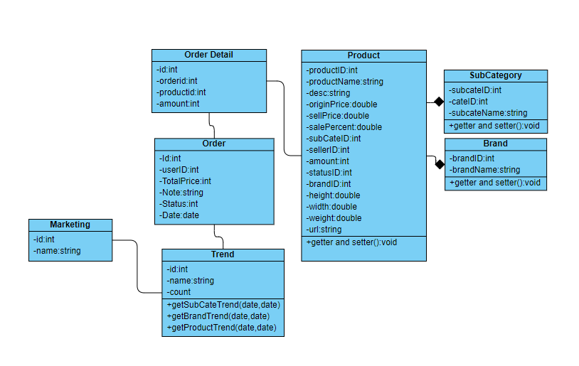

### b. Class Specifications

|  |  |  |
| --- | --- | --- |
| **No** | **Method** | **Description** |
| *01* | *getSubCateTrend(date,date)* | *get Sub Category Ordered Trend between 2 date* |
| *02* | *getBrandTrend(date,date)* | *get Brand Ordered Trend between 2 date* |
| *03* | *getProductTrend(date,date)* | *get Top 10 Product Ordered Trend between 2 date* |

### c. Sequence Diagram(s)

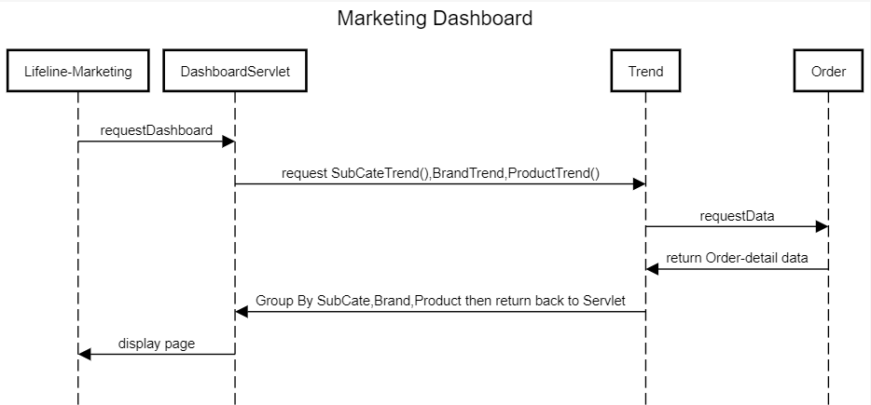

### d. Database queries

SELECT odr.SubCategoryID,SubCategoryName,SUM(odr.Quantity) AS Count FROM ( SELECT od.ProductID,od.ProductName,od.Quantity,od.Date,SubCategoryID,BrandID FROM (SELECT ProductID,ProductName,Quantity,Date FROM dbo.Orders JOIN dbo.Order_Detail ON Order_Detail.Order_ID = Orders.ID ) od JOIN dbo.Product ON Product.ProductID = od.ProductID WHERE od.Date BETWEEN CAST( ? AS DATE) AND CAST( ? AS DATE) ) odr JOIN dbo.SubCategory ON SubCategory.SubCategoryID = odr.SubCategoryID GROUP BY odr.SubCategoryID,SubCategoryName ORDER BY COUNT DESC

SELECT odr.BrandID,BrandName,SUM(odr.Quantity) AS Count FROM (SELECT od.ProductID,od.ProductName,od.Quantity,od.Date,SubCategoryID,BrandID FROM (SELECT ProductID,ProductName,Quantity,Date FROM dbo.Orders JOIN dbo.Order_Detail ON Order_Detail.Order_ID = Orders.ID ) od JOIN dbo.Product ON Product.ProductID = od.ProductID WHERE od.Date BETWEEN CAST( ? AS DATE) AND CAST( ? AS DATE) ) odr JOIN dbo.Brand ON Brand.BrandID = odr.BrandID GROUP BY odr.BrandID,BrandName ORDER BY COUNT DESC

SELECT TOP 10 odr.ProductID,odr.ProductName,SUM(odr.Quantity) AS Count FROM ( SELECT od.ProductID,od.ProductName,od.Quantity,od.Date,SubCategoryID,BrandID FROM (SELECT ProductID,ProductName,Quantity,Date FROM dbo.Orders JOIN dbo.Order_Detail ON Order_Detail.Order_ID = Orders.ID ) od JOIN dbo.Product ON Product.ProductID = od.ProductID WHERE od.Date BETWEEN CAST(? AS DATE) AND CAST( ? AS DATE) ) odr GROUP BY odr.ProductID, odr.ProductName ORDER BY COUNT DESC

## 43. DeliveryJob

### a. Class Diagram

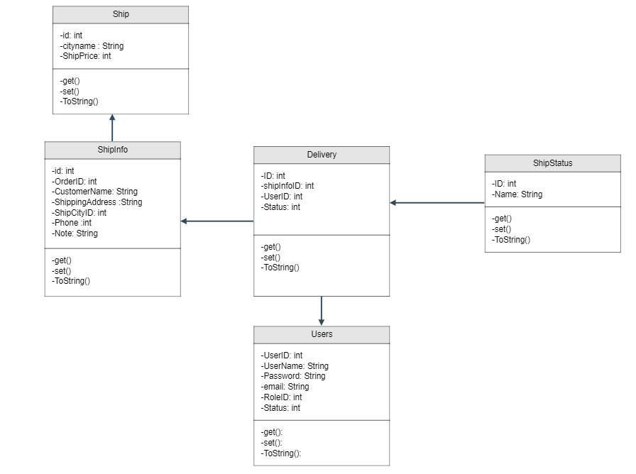

### b. Class Specifications

|  |  |  |
| --- | --- | --- |
| **No** | **Method** | **Description** |
| *01* | *getRoleByUserName()* | *get user by user id* |
| *02* | *getJobByShipper(id)* | *get list job by shipper id* |
| *03* | *getShipInfoByJob(listjob)* | *get list shipInfo by list job* |
| *04* | *getShip()* | *get all ship* |

### c. Sequence Diagram(s)

### d. Database queries

* select * From delivery where UserID = ?
* select * from ShipInfo where ID = ?
* SELECT * from dbo.Ship

## 44. Delivery Details

### a. Class Diagram



### b. Class Specifications

|  |  |  |
| --- | --- | --- |
| **No** | **Method** | **Description** |
| *01* | *getOrderPackaging()* | *get order packaging()* |
| *02* | *CheckOrderExist( orderID, listo)* | *Check Order is Exist in list order* |
| *03* | *getShipInfoByOdID(id)* | *get ShipInfo by orderID* |
| *04* | *getOrderByOrderID(oid)* | *get Order By order ID* |
| *05* | *getShip()* | *get all ship* |

### c. Sequence Diagram(s)

### d. Database queries

* select * from ShipInfo where Order_ID = ?
* select o.ID , o.UserID , o.TotalPrice , o.Note , o.Status , o.Date , d.Order_ID , d.ProductID , d.ProductName ,d.ProductPrice , d.Quantity from Orders o join Order_Detail d on d.Order_ID = o.ID where o.ID = ?
* SELECT * from dbo.Ship

# III. Database Tables

## 1. Database Schema

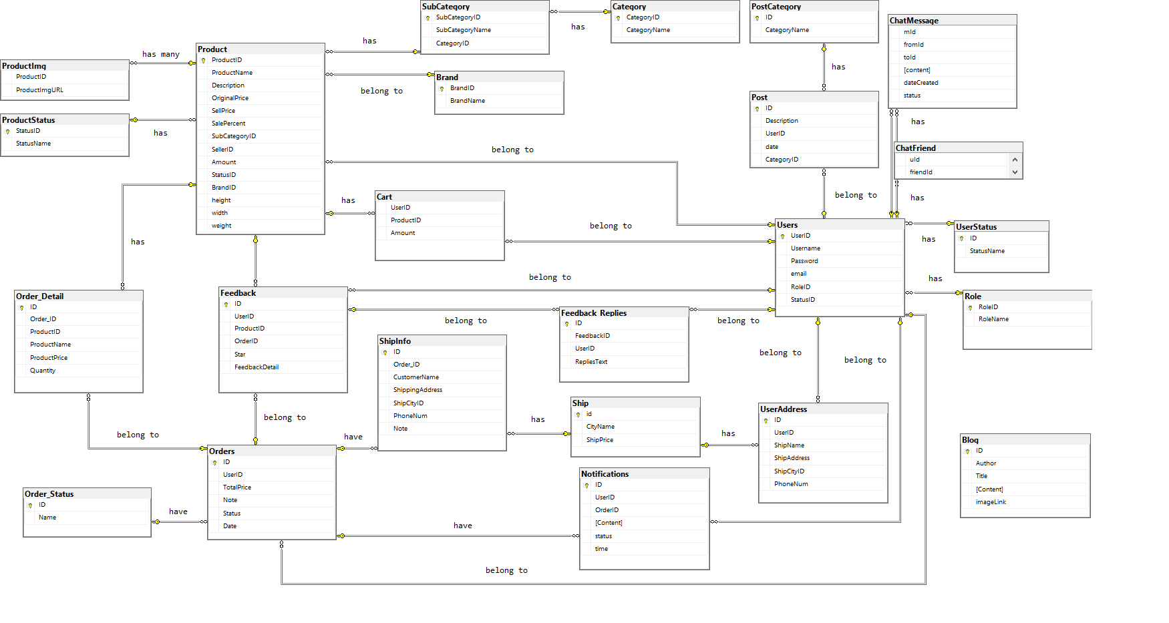

## 2. Table Description

|  |  |  |
| --- | --- | --- |
| **No** | **Table** | **Description** |
| *01* | *Blog* | *Blog content + image*  *- Primary keys: ID*  *- Foreign keys:* |
| *02* | *Role* | *Role of a user ( Admin,Marketing,Sale,Customer )*  *- Primary keys: RoleID*  *- Foreign keys:* |
| *03* | *UserStatus* | *Account activation status*  *- Primary keys: ID*  *- Foreign keys:* |
| *04* | *Ship* | *Shipping price for each city*  *- Primary keys: id*  *- Foreign keys:* |
| *05* | *Order_Detail* | *Detail of each product in order*  *- Primary keys:*  *- Foreign keys: OrderID, ProductID* |
| *06* | *UserAddress* | *Address for each user*  *- Primary keys:ID*  *- Foreign keys: UserID, ShipCityID* |
| *07* | *Users* | *Users*  *- Primary keys: UserID*  *- Foreign keys: RoleID,StatusID* |
| *08* | *Notification* | *Notification data*  *- Primary keys: ID*  *- Foreign keys: OrderID, UserID* |
| *09* | *ShipInfo* | *Shipping info for each order*  *- Primary keys: ID*  *- Foreign keys: Order_ID, ShipCityID* |
| *10* | *Order* | *Order data*  *- Primary keys: ID*  *- Foreign keys: UserID,Status* |
| *11* | *Feedback* | *Feedback of a product order*  *- Primary keys: ID*  *- Foreign keys: UserID,ProductID, OrderID* |
| *12* | *Feedback_Replies* | *Replies of feedbacks*  *- Primary keys: id*  *- Foreign keys: FeedbackID,UserID* |
| *13* | *Order_Status* | *Status of a order*  *- Primary keys: ID*  *- Foreign keys:* |
| *14* | *Product* | *Product Data*  *- Primary keys: ProductID*  *- Foreign keys: SubCategoryID,SellerID,StatusID,BrandID* |
| *15* | *Category* | *Category Data*  *- Primary keys: CategoryID*  *- Foreign keys:* |
| *16* | *SubCategory* | *Sub Category ID*  *- Primary keys: SubCategoryID*  *- Foreign keys: CategoryID* |
| *17* | *Productimg* | *Image of products*  *- Primary keys:*  *- Foreign keys: ProductID* |
| *18* | *ProductStatus* | *Status of a product*  *- Primary keys: StatusID*  *- Foreign keys: StatusName* |
| *19* | *Brand* | *Brand data*  *- Primary keys: BrandID*  *- Foreign keys:* |
| *20* | *Cart* | *Cart info for each user*  *- Primary keys: UserID*  *- Foreign keys: ProductID* |
| *21* | *CBanner* | *Carousel Banner*  *-Primary keys: BannerID* |
| *22* | *Banner* | *Ads Banner*  *-Primary keys: BannerID* |
| *23* | *ChatMessage* | *Message*  *- Primary keys:*  *- Foreign keys: fromId, toId* |
| *24* | *ChatFriend* | *Chat’s Members*  *- Primary keys:*  *- Foreign keys: uId,FriendId* |

## 